**AWS Data Analytic Platform for The City of Vancouver: Phase 2**

Juhi Shayama Ali- 2315421

Shwetha Mohankumar- 2311254

Niraj Pandey -2313172

Saugat Khadka - 2308236

University Canada West

BUSI 653: Cloud Computing Technologies – (HBD-WINTER25-01)

Professor. Mahmood Mortazavi Dehkordi

March 25, 2024

Table of Contents

DAP Implementation: Team Member 1# Niraj Pandey (Business License dataset) 3

Step 5: Data Analysis 3

Step 6: Data Security 7

Step 7: Data Governance 9

Step 8: Data Monitoring 12

FeedBack from part 1: Niraj Pandey 3

Feedback from Part 1: Saugat Khadka Individual feedback 16

DAP Implementation: Team Member 2# Saugat Khadka (Community Farmers market and Food Market dataset) 19

Step 5: Data Analysis: 19

Step 6: Data Security: 23

Step 7: Data Governance: 25

Step 8: Data Monitoring: 28

DAP Implementation: Team Member 3 # Shwetha Mohankumar (Council Voting Record dataset) 30

Design to implement 30

Step 5: Data Analysis 31

Step 6: Data Security 36

Step 7 - Data Governance: 46

Step 8 - Data Monitoring 50

**Purpose in Data Monitoring:** 51

DAP Implementation: Team Member 1# Juhi Ali (Operation Management dataset) 53

Step 5: Data Analysis 53

Step 6: Data Security 55

Step 7: Data Governance 57

Step 8: Data Monitoring 60

DAP Architecture Analysis: (Teamwork): 63

Operational Excellence: 63

Security 64

Reliability: 65

Performance efficiency: 66

Cost Optimization: 67

# DAP Implementation: Team Member 1# Niraj Pandey (Business License dataset)

## Step 5: Data Analysis

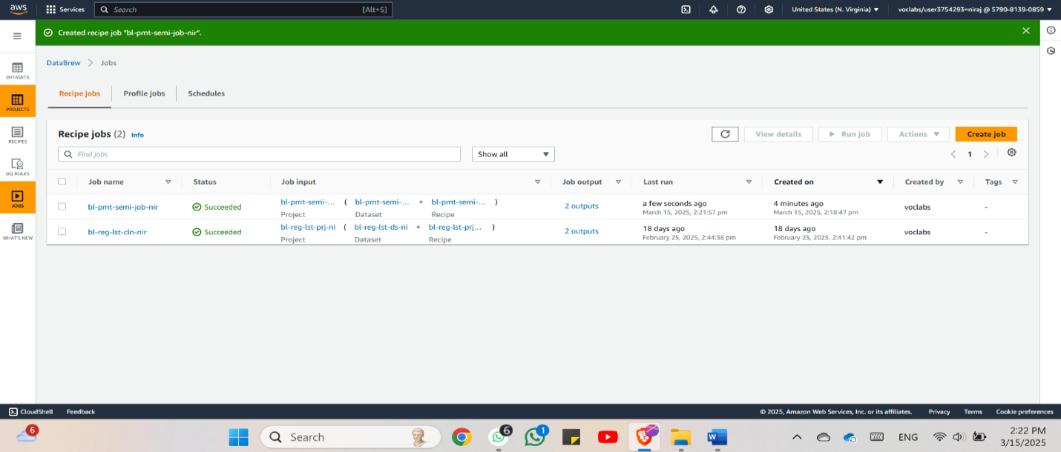

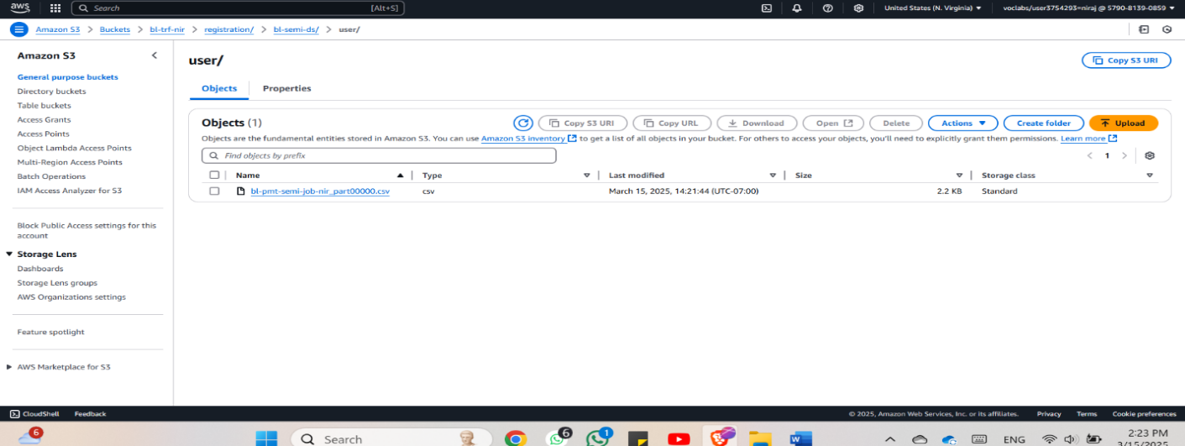*Figure 1.2*

*Figure 1.3*

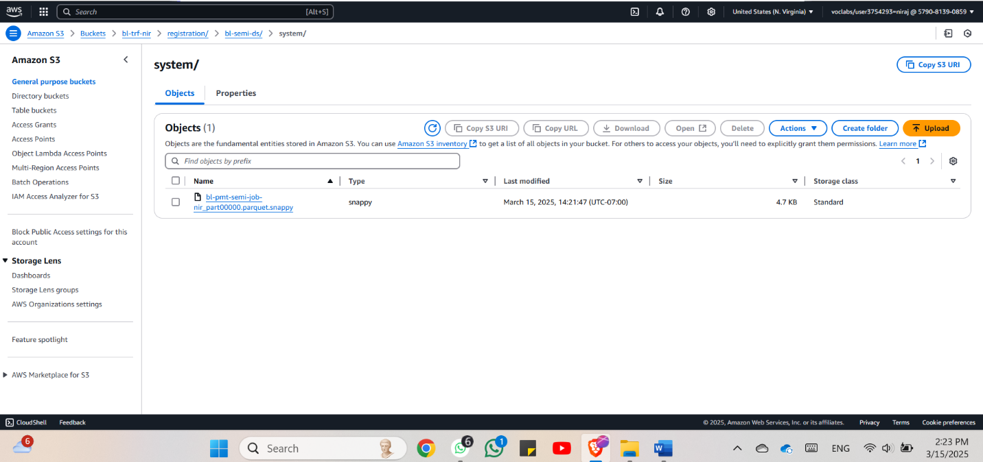

*Figure 1.4*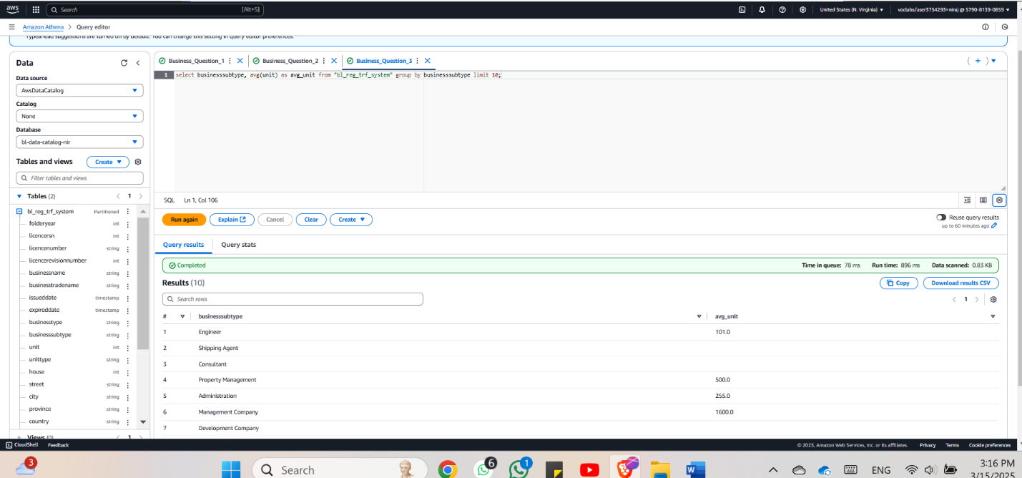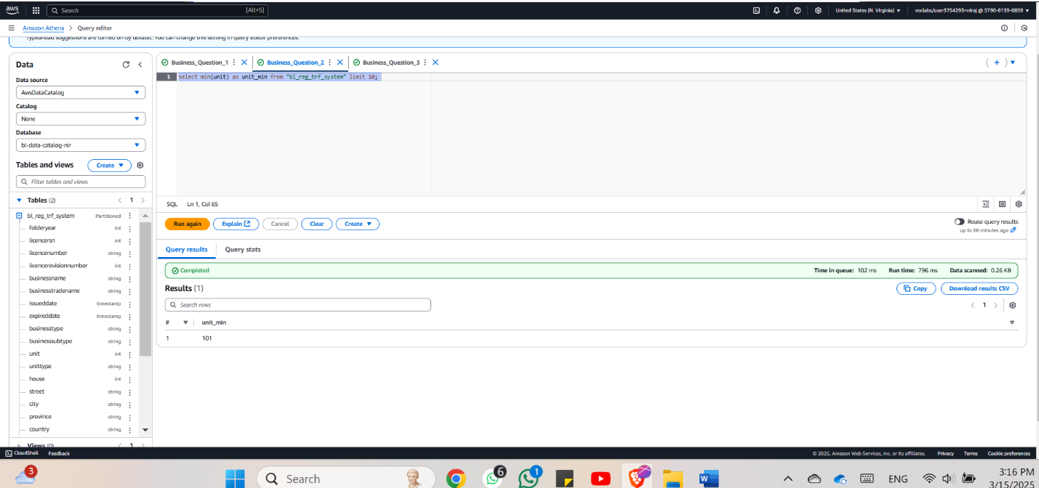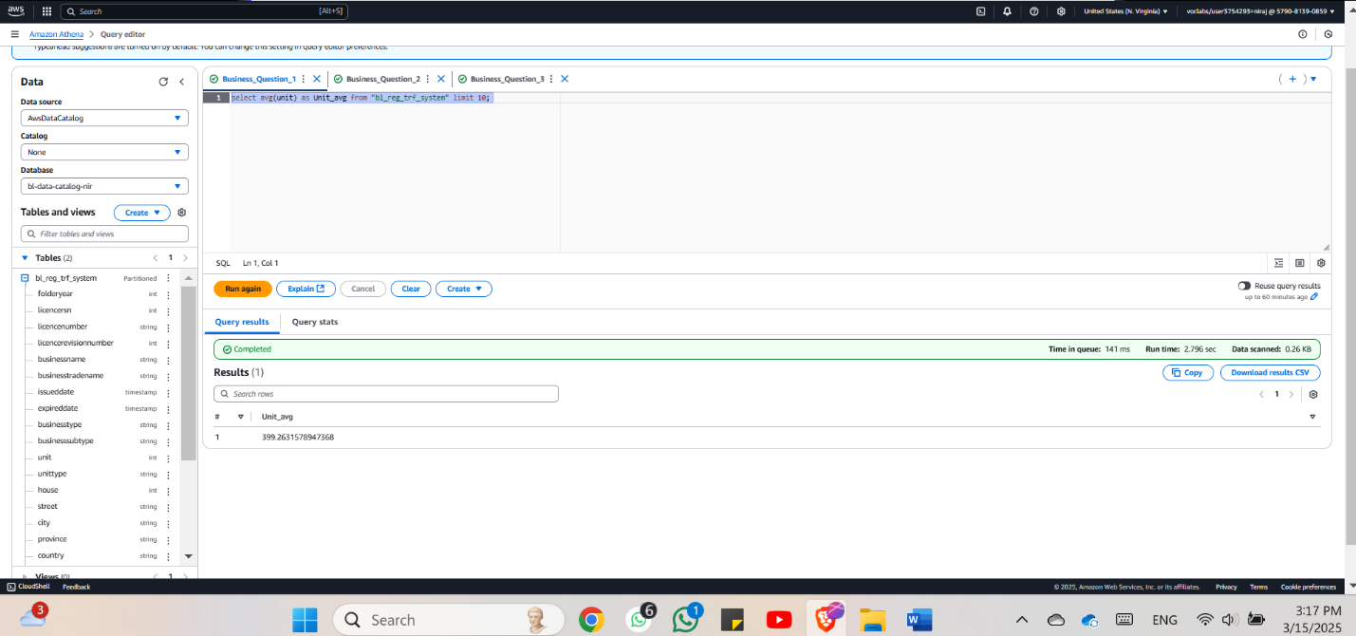

*Figure 1.5*

*Figure 1.6*

*Figure 1.7*

The screenshots present a smooth process connecting AWS services for cleaning and storing and analyzing semi-structured business data. The bl-pmt-semi-job-nir DataBrew recipe job performs the initial phase of data cleansing on raw input before standardization processes begin. The structured analytics-ready format is achieved through this needed step. The cleaned data received was processed in Amazon S3 through two storage formats: Parquet for quick large-scale querying in the system/ and CSV for user/ folder compatibility with basic tools. The combination of CSV and Parquet file formats enables complete flexibility by granting end-users access to complex processing or basic reporting needs.

Then, Amazon Athena was employed for running interactive SQL queries directly to the data stored in S3. Some of the queries evident include the average and minimum values of the unit field and the group by business type. These assist in disclosing such statistics and deviations, for instance, which business kinds operate at denser capacities or have more units. This makes Athena a very useful tool for ad hoc queries because it is serverless and can query files formatted in Parquet.

To summarize this AWS-based workflow offers a great solution for the transformation and analysis of semi-structured data in a low-code, highly scalable, and more importantly cost-effective manner. It is effective in use cases where the regulation, control, or operational datasets are to be managed in a common format that is readily accessible and enables real-time analysis.

## Step 6: Data Security

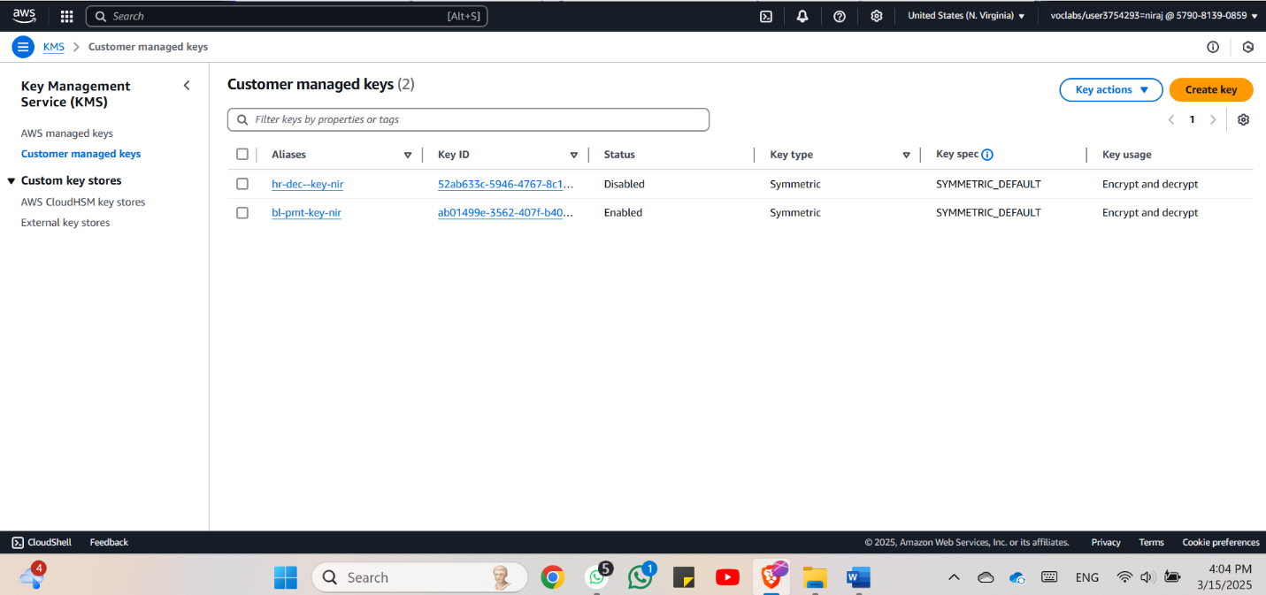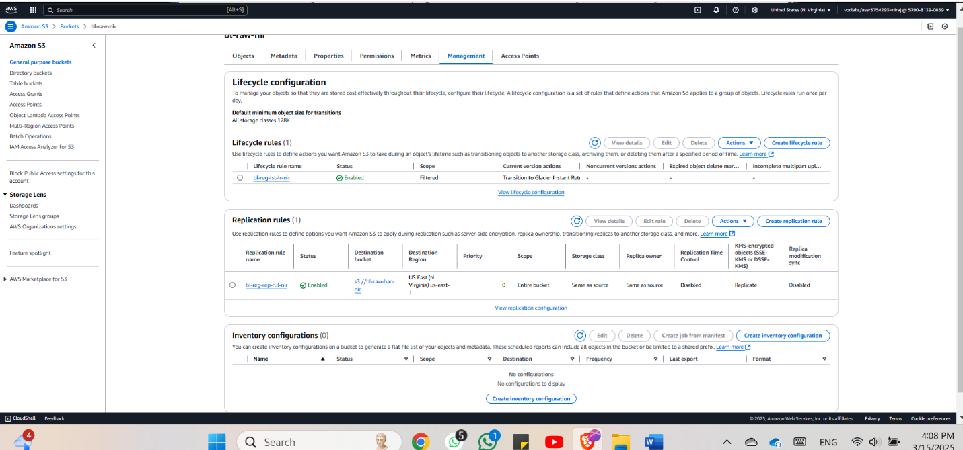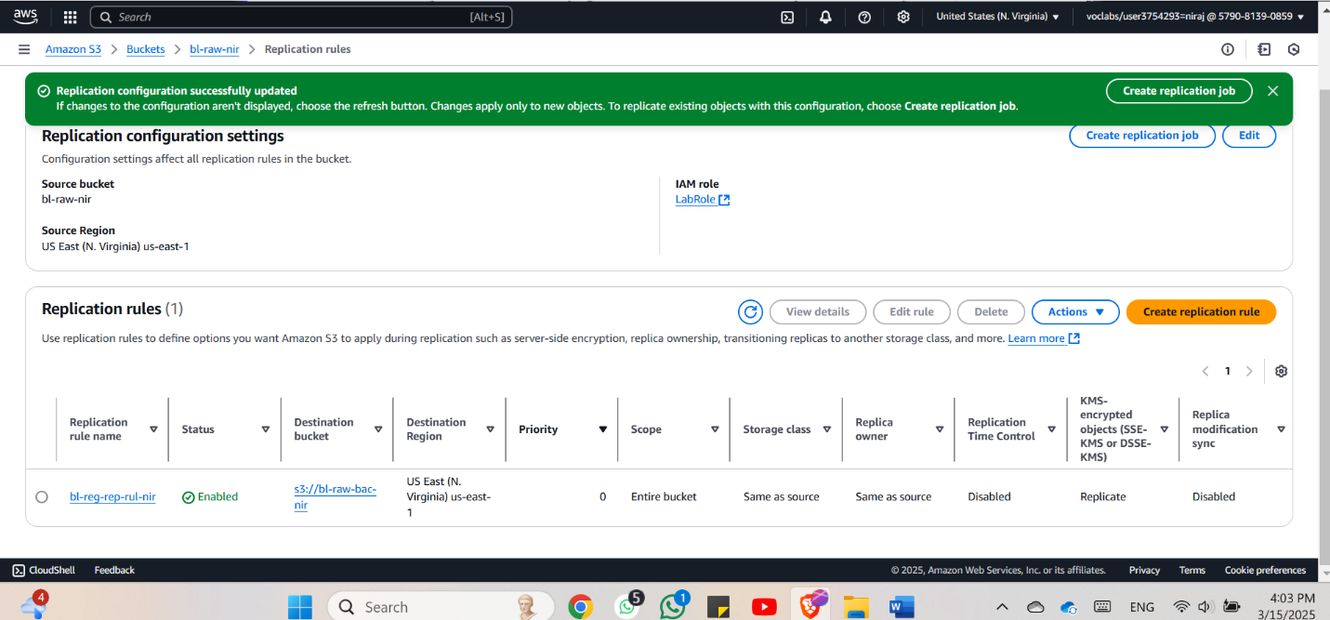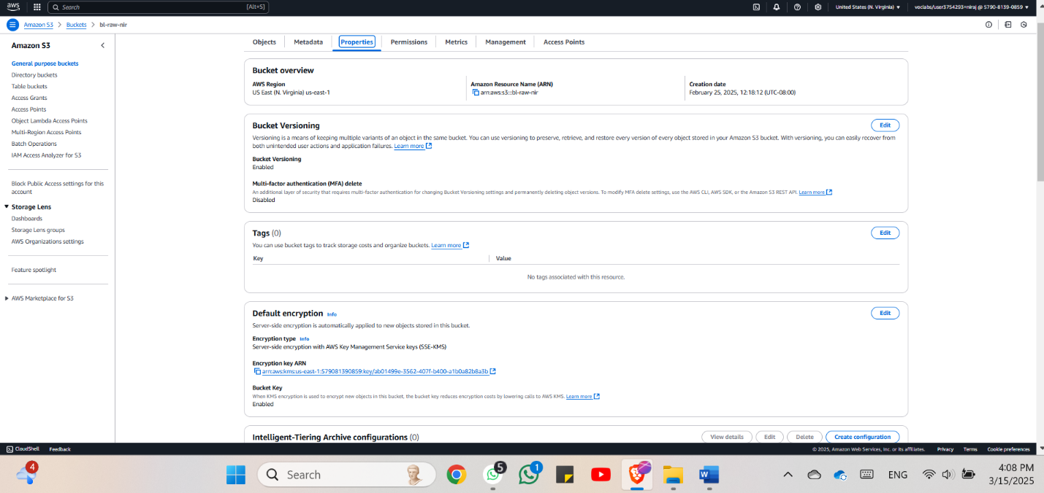

*Figure 1.9*

*Figure 1.8*

*Figure 2*

*Figure 2.1*

The screenshots reveal a strong AWS setup with regard to security, data retrieval, and cost optimization with the help of KMS, S3 versioning, replication, and lifecycle policies.

There are two customer managed keys present in AWS KMS and as noted previously bl-pmt-key-nir is enabled for encryption and decryption. This key is used to implement SSE-KMS Buckets at the S3 bucket bl-raw-nir to guarantee that all the objects it contains are encrypted at rest.

S3 for the bucket also has versioning enabled which saves all versions of the objects in a bucket so that overwriting or deleting object is protected against. To enhance the security of the data processing, a replication rule copies objects from the bucket bl-raw-nir to the backup bucket bl-raw-bac-nir within the same zone. Data replication supports encrypted files so that data can be protected during the transfer process. Further, a lifecycle rule (bl-reg-lst-lr-nir) is set to move the data older than this moving them to Glacier Instant Retrieval and manage the storage costs without requiring any user involvement. In summary, the configuration makes sure that the stored data is safe, easy to restore, and cost-efficient, consistent with the principles of cloud data protection and recovery.

Step 7: Data Governance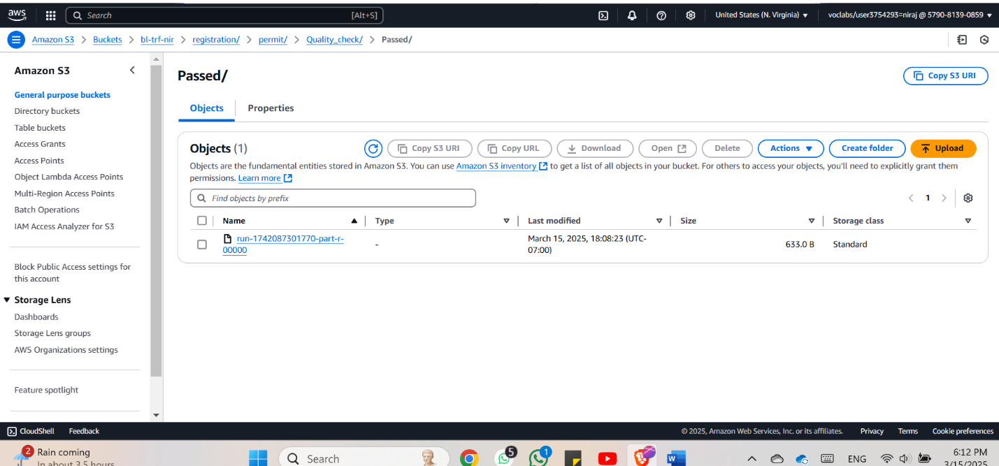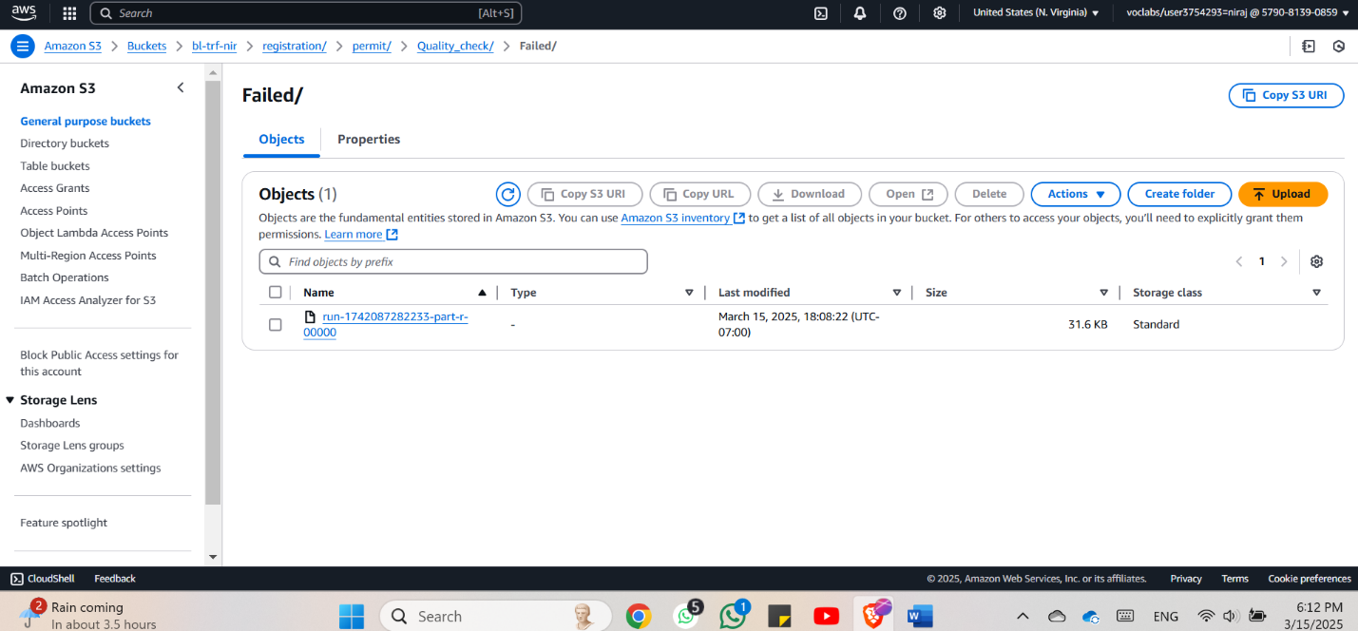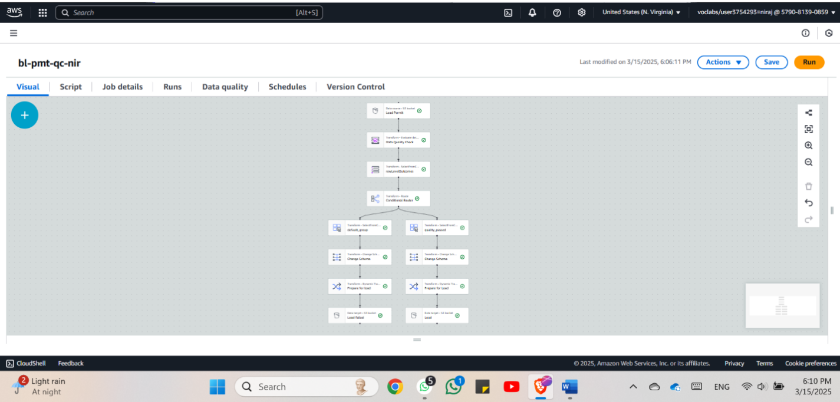

*Figure 2.2*

*Figure 2.3*

*Figure 2.4*

Screenshots describe step by step checkup and merging of the data quality from the DW stage done by a visual ETL job (bl-pmt-qc-nir) in AWS services. This pipe line aims to check the quality of the input data and then filter it automatically and eliminate any inappropriate data that may not qualify to proceed to the next process.

The data loading of the ETL pipeline (as depicted in the screenshot on the visual editor above) starts from an S3 bucket known as Load Permit. This is followed by a data quality check and a conditional routing check on the ability of the records to satisfy laid down quality measures. If the data meets the quality check (quality passed), it continues with the schema transformation and prepares steps before being stored at S3 in the “Passed” folder (Quality check/Passed/). In the case of erroneous data, the incoming stream is depicted in a particular route to another branch marked as ‘Failed’ path” (Quality check/Failed/). This means to break off or divide, in order to avoid closely related records from keeping each other, or to be able to correct any error.

The S3 screenshots support this process’s outcome. In the Passed folder, a brief output file of only 633 bytes implies that only a few records passed the quality assessment. The Failed folder has a file size which is almost 31.6 KB, which means that more records were tagged as invalid. This approach makes it possible to ensure that data quality is checked before it is passed to other applications such as analysis, reporting or even use in the making of decision through the use of AI. Facilitating clean pipelines, eliminating wreckage from invalid data around the pipelines, easing debugging and keeping data clean and trusted all while achieving this in conjunction with automating validation in a low code, scalable configuration within AWS.

## Step 8: Data Monitoring

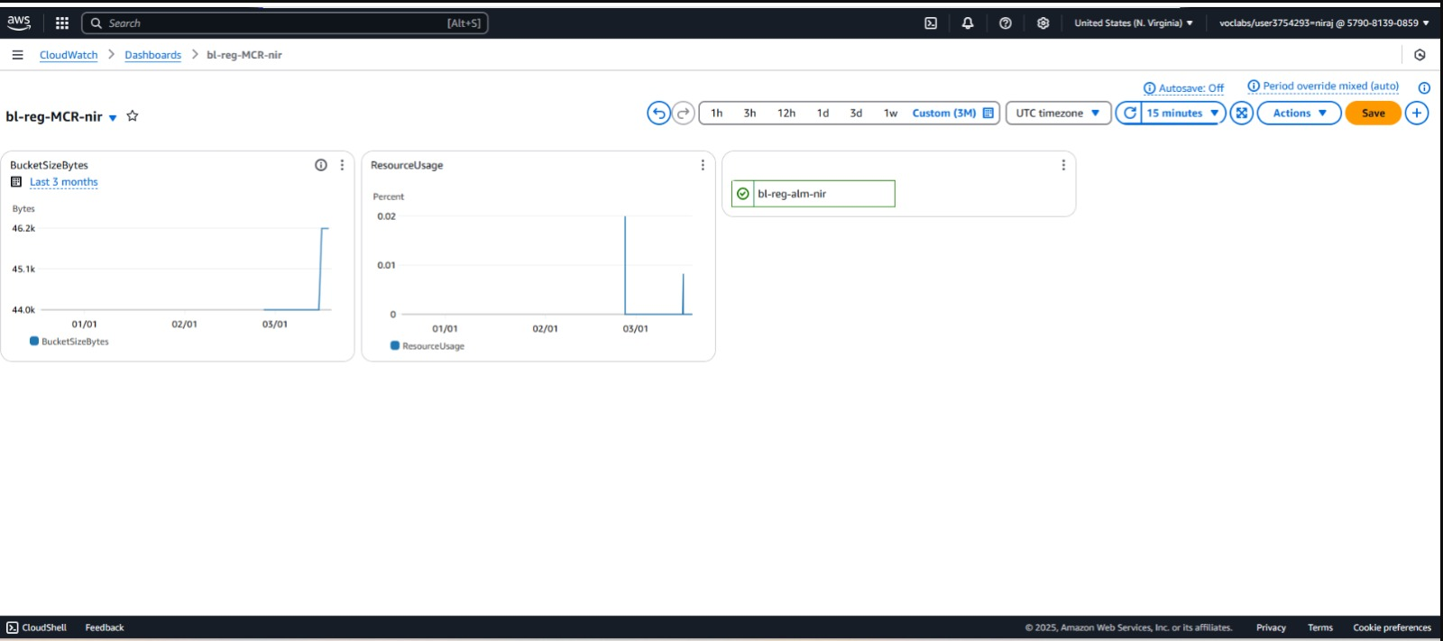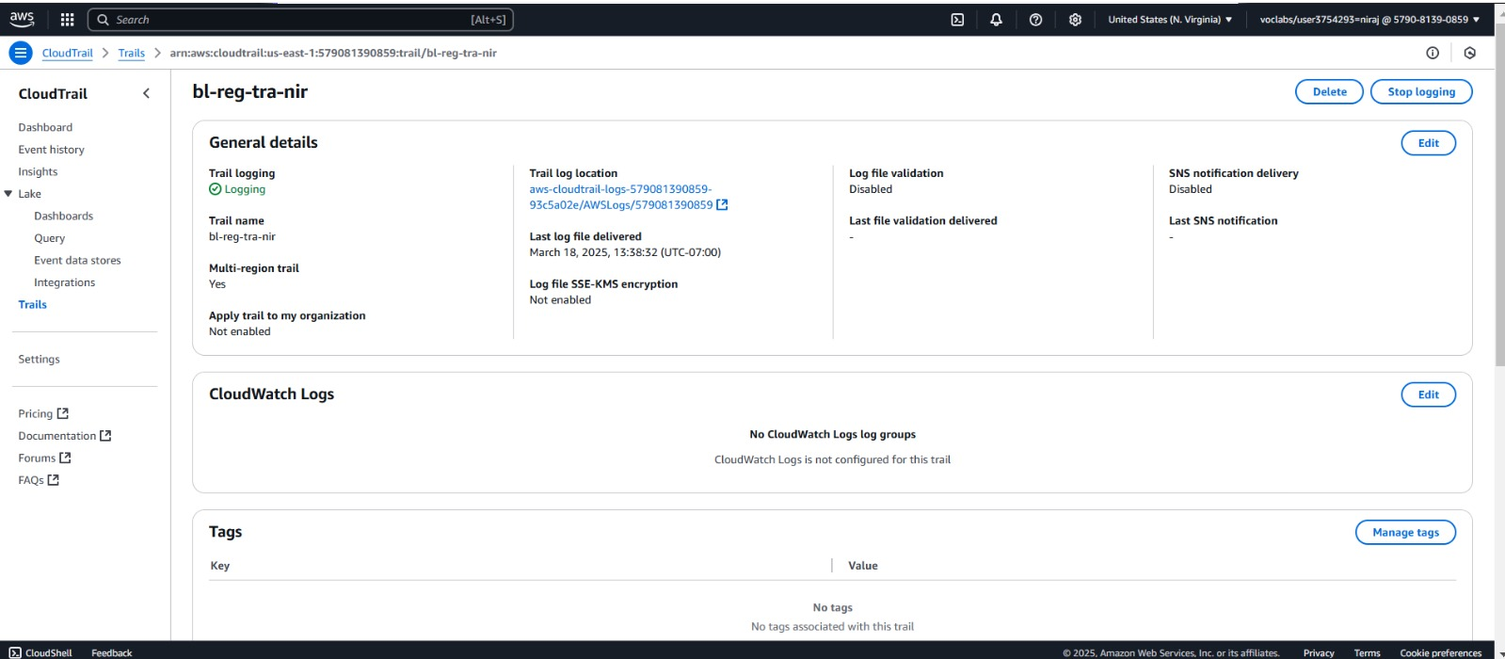

*Figure 2.6*

*Figure 2.5*

In the screenshots, the monitoring and logging procedures for the dataset are illustrated through use of AWS CloudTrail and Amazon CloudWatch. These services provide governance, observability, and operational insight over data processing throughout the permit registration pipeline and addressed resources.

In the figure 2.5 a trail named bl-reg-tra-nir is created in AWS CloudTrail and it is enabled to start logging API event from any region. This records all managing actions, like object upload, policy updates or changes, or changes in computing user access, to help in auditing, monitoring of security, compliance, and diagnosing of problems. The trail is associated with an S3 bucket for the logs to be stored in but it does not have a log file integrity check, SNS notification, or CloudWatch Logs. However, it ensures that the most important actions concerning the dataset and its supporting infrastructure are recorded and can be audited where necessary.

Figure 2.6 is an AWS CloudWatch and it is named bl-reg-MCR-nir which allows you to track several factors ranging from the size of the bucket to the resources taken after a given period of three months. Despite its insufficiency in real-time work, the visualization gives many insights into storage consumption or service performance hence helping the system administrators address issues of scale, cost, or concerns that may require more profound investigation. It can be connected to some alarm (bl-reg-alm-nir) to notify the users in advance in case the threshold is reached, allowing for better reactions to such problems.

Altogether, the services facilitate the effectiveness of prospecting and operational oversight of the permit registration dataset. CloudTrail gives what happened and who did it record and CloudWatch supplies ‘how it is performing and when to act. Both features ensure an encrypted and highly efficient data relay system, pertinent for consistent and certain work done in regulated contexts or large-scale big data handling.

# 

**Summarized graph for the Business License Dataset**

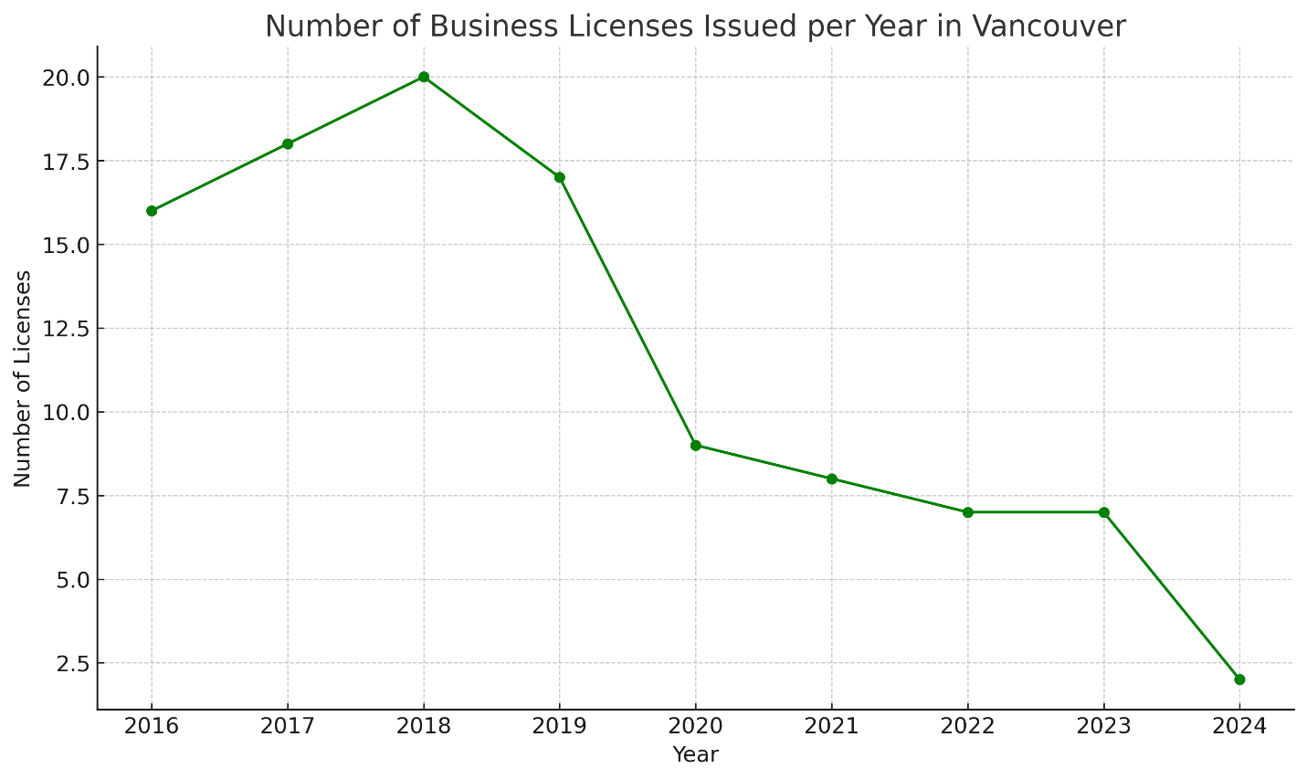

# *Figure 1.1*

The City of Vancouver total business license counts in annual reports present historical patterns of local business actions. The line points on the graph display yearly totals for business licenses which reveals changes in business sector expansion or reduction. The movement of business license numbers throughout time hints between economic development combined with entrepreneur enthusiasm or possible adjustments in market need and governmental regulations and economic uncertainties. The graph provides essential information about the city's business sector transformations during individual years.

As policymakers conduct research together with community planners and analysts they gain the capacity to determine the city's economic status and develop plans for forthcoming support or oversight. The identification method reveals important years when population changes occurred because of economic events along with urban development or social effects that transformed the new or renewing business trend.

# Feedback from Part 1: Saugat Khadka Individual feedback

*Figure 1: Summarized graph of the Community Food Market and farmers Market dataset for the City of Vancouver.*

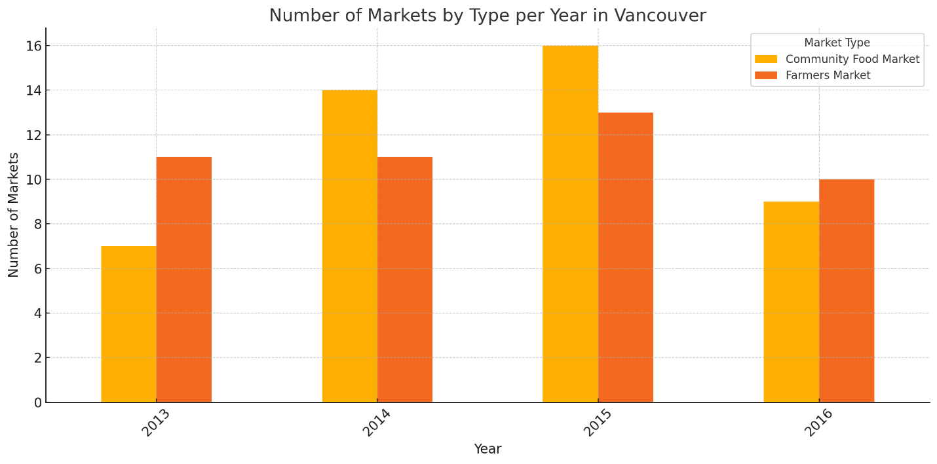

This bar chart shows the population changes of Community Food Markets and Farmers Markets during 2013 to 2016 in Vancouver. Farmers Markets presented steady attendance statistics during these four years through constant annual enrollment numbers. The number of Community Food Markets underwent substantial modifications across these years. The highest recorded number of Community Food Markets occurred during 2015 when their count reached its all-time peak out of every market type for the displayed years. A downward trend emerged in 2016 after community programs, funding or local priorities underwent possible changes. Community Food Markets operated as more responsive entities to external developments yet Farmers Markets maintained stable continuous nationwide demand throughout the observation period.

This shift in local food initiative benchmarks indicates changing approaches of these initiatives to serve community requirements. Community Food Markets experienced increased activity because there was a rise in local initiatives that expanded food access in disadvantaged areas. The decreasing number of activities could represent the completion of temporary projects or their transformation into alternative types of service distribution. The presented data demonstrates how changes in market types affect the local food environment while highlighting the factors that drive these changes in market presence.

*Figure 2: Job Profiling*

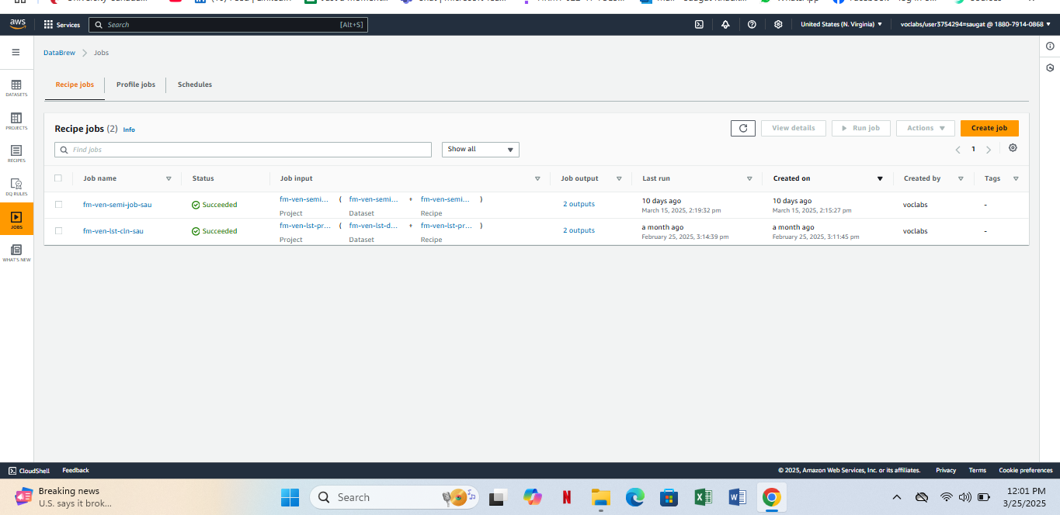

The image reveals the AWS Glue DataBrew user interface which displays completed "Recipe jobs" in the "Recipe jobs" tab showing two data processing projects. There exist two job procedures named fm-ven-semi-job-sau and fm-ven-lst-cln-sau which analyze City of Vancouver datasets about community food markets and farmers markets. The process of examining and transforming raw datasets through defined "recipes" constitutes job profiling because it cleans and standardizes data for analysis purposes. The process assures accurate and high-quality information along with data consistency that remains crucial for identifying patterns and distribution and availability of food access options throughout Vancouver. The examination of these datasets enables users to acquire significant information for planning purposes, together with policy-making requirements and community service needs.

*Figure 3: Crawlers*

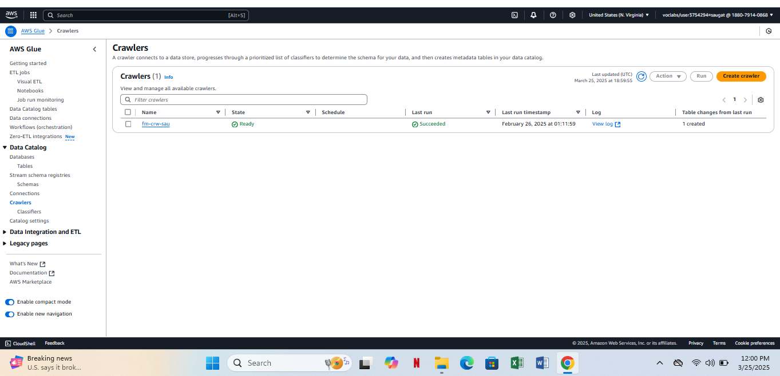

The picture above displays AWS Glue Crawlers running the crawler named fm-crw-sau successfully. Through the AWS Glue crawler you can connect your data source for the crawler to determine data structure and create or update metadata tables in the AWS Glue Data Catalog. The crawler used its operations to inspect community food markets and farmers markets data in Vancouver which resulted in schema discovery followed by Data Catalog registration. The data becomes accessible for data transformations and analytics and profiling by providing effortless usability to services including AWS Glue DataBrew or Athena through this essential step.

# DAP Implementation: Team Member 2# Saugat Khadka (Community Farmers market and Food Market dataset)

## Step 5: Data Analysis:

*Figure 1: Semi-structure job run*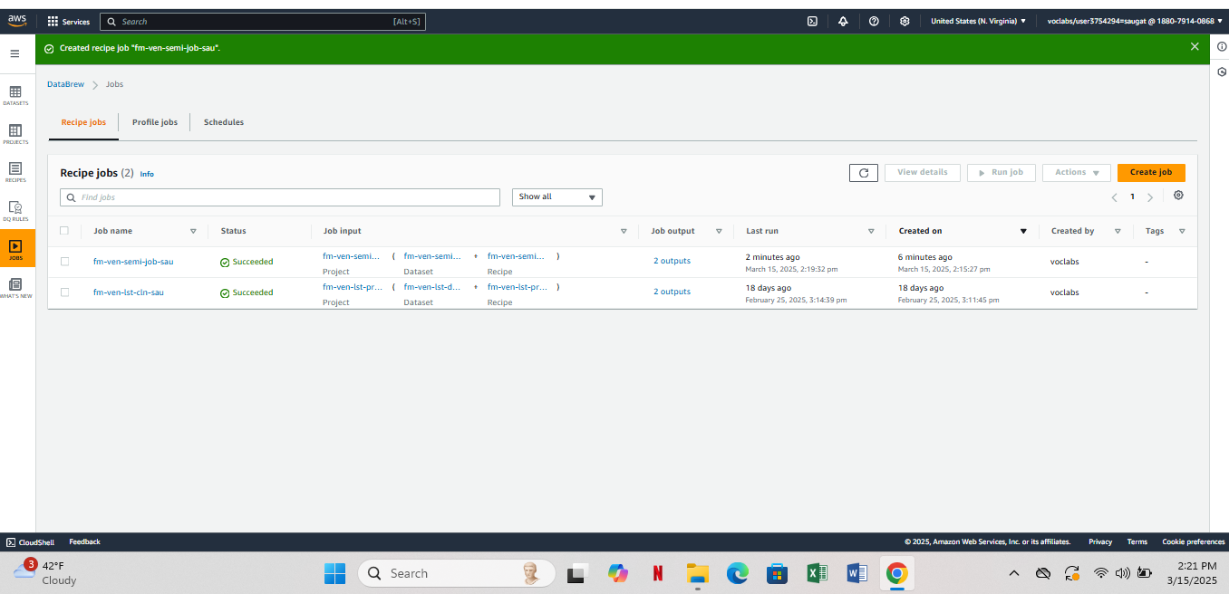

*Figure 2: System folder for semi-structure dataset*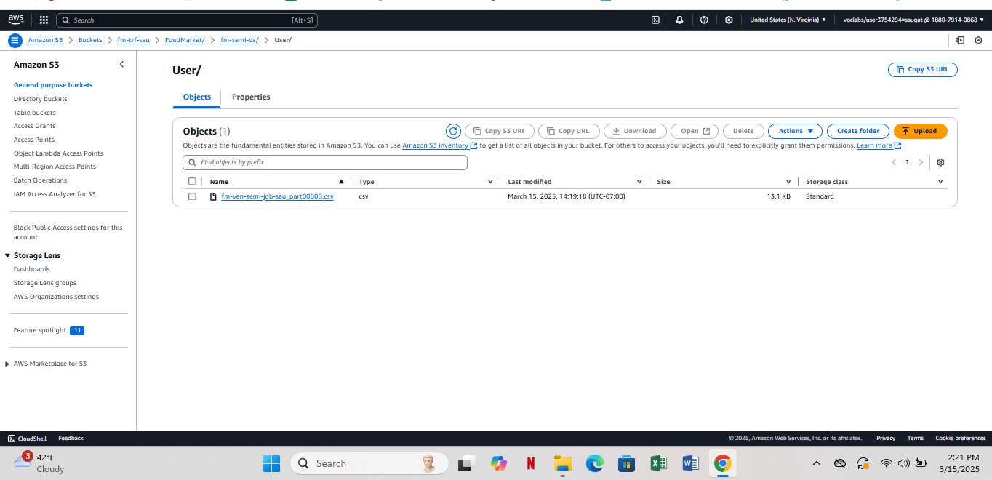

*Figure 3: User folder for Semi-structure dataset*

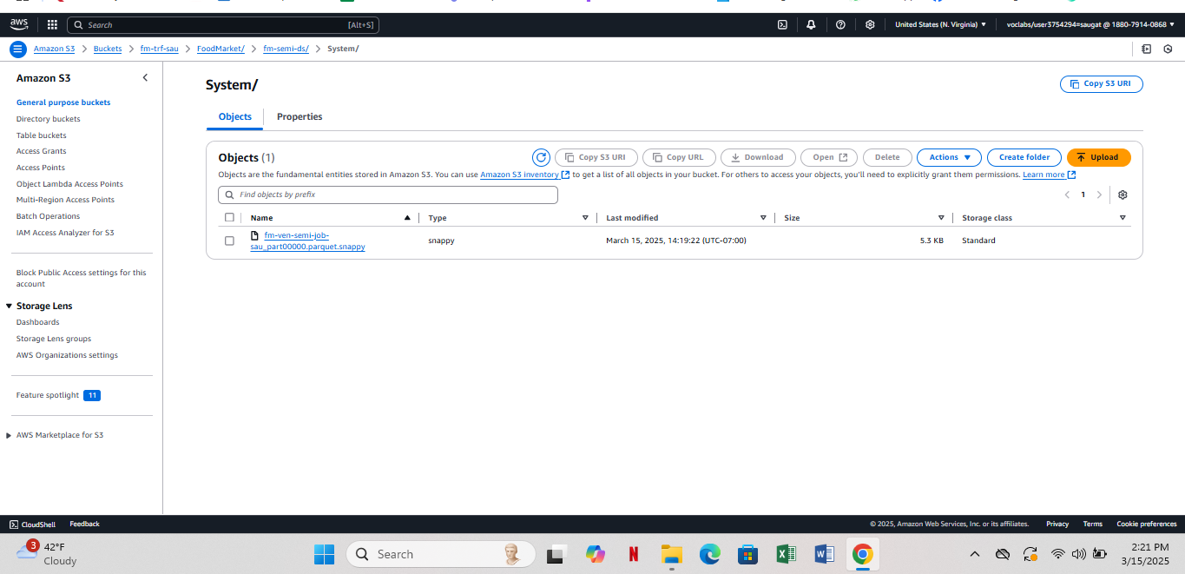

*Figure 4: Query 1*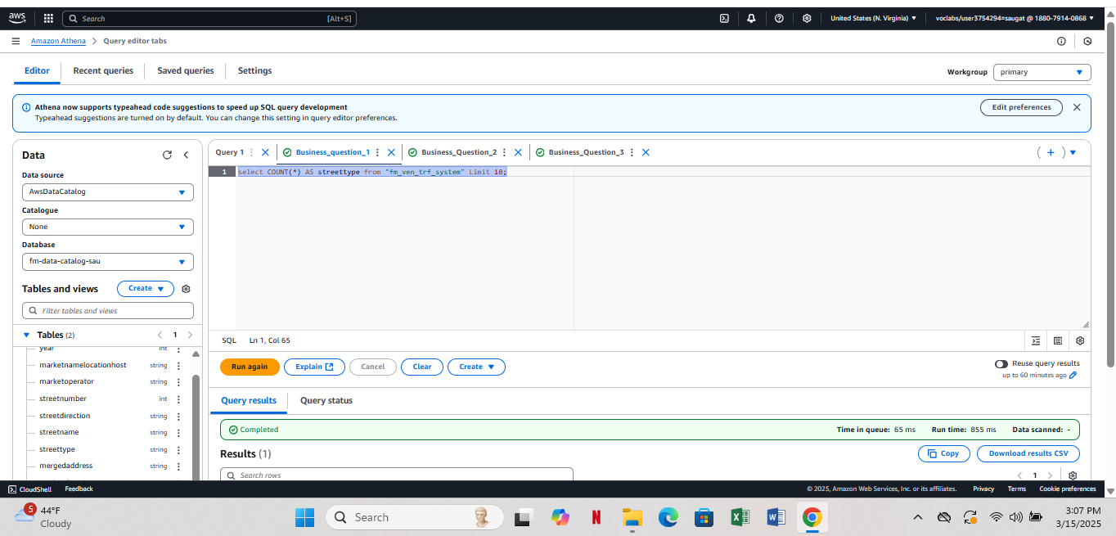

*Figure 5: Query 2*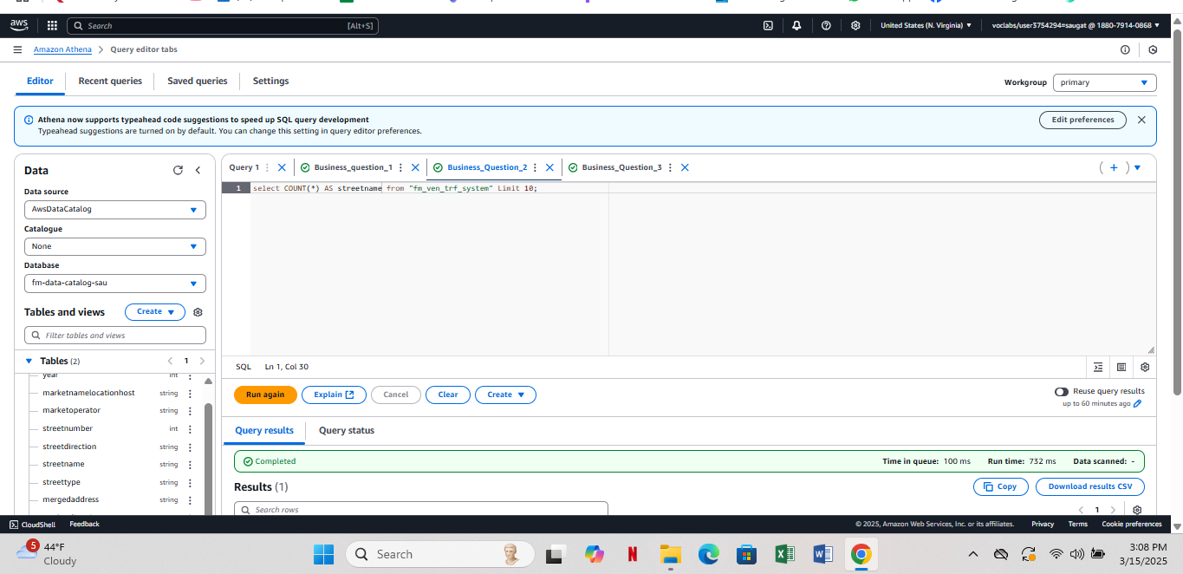

*Figure 6: Query 3*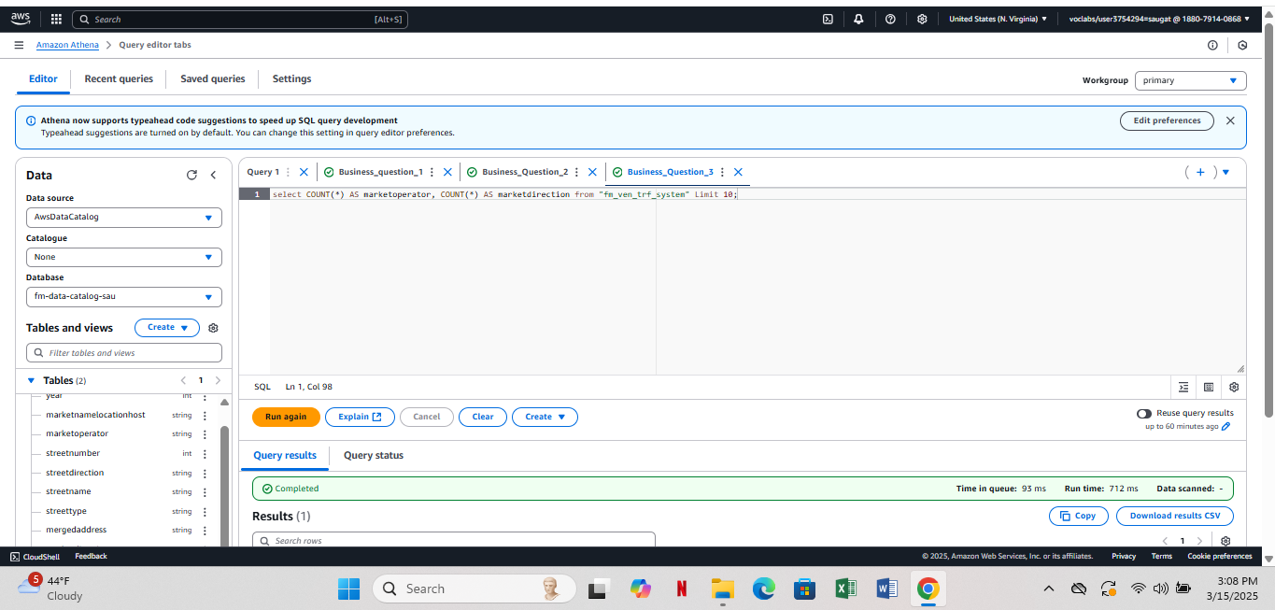

Data analysis of semi-structured data within AWS operates through defined methods which simplify both data handling and data transformation and insight extraction. For reference purposes the Vancouver community food market dataset serves as the foundation. AWS Glue DataBrew serves as the first step of processing where users generate recipe jobs for cleaning and preparing the dataset. The standardization of dataset with transformations like filtering, formatting and enrichment is performed by recipe jobs including fm-ven-semi-job-sau. The jobs perform essential tasks to prepare the dataset containing market details such as their locations with products and hours by making it structurally viable for analysis purposes.

After processing the data becomes available in Amazon S3 as various file types. The dataset uses Parquet (snappy compressed) and CSV as its data storage formats. Data is stored in Parquet due to enhanced analytics efficiency together with low costs but CSV serves both readability needs and tool compatibility requirements. Users analyze structured and semi-structured data from S3 using Amazon Athena because it operates as a serverless SQL query engine for such datasets. Athena shows SQL queries which perform traffic counts of market operators together with street names and additional important elements. The derived insights about Vancouver’s food markets can be obtained even though users avoid creating complex databases.

This workflow from data preparation in AWS Glue DataBrew, storage in S3, to query execution in Athena enables efficient processing and analysis of semi-structured data. The dataset uses AWS services to become more manageable and analytical thus helping stakeholders to understand Vancouver's food market distribution and accessibility along with their offerings. Data accuracy together with improved operational decision-making for food markets and customer relationships exists because of this simplified system.

## Step 6: Data Security:

*Figure 7: Key Management Security*

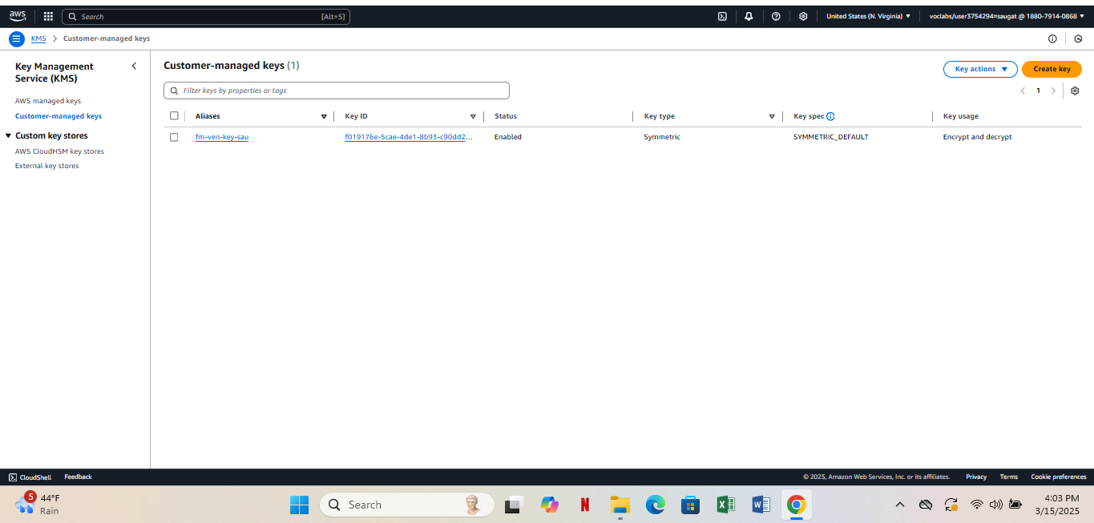

*Figure 8: Replication Rules*

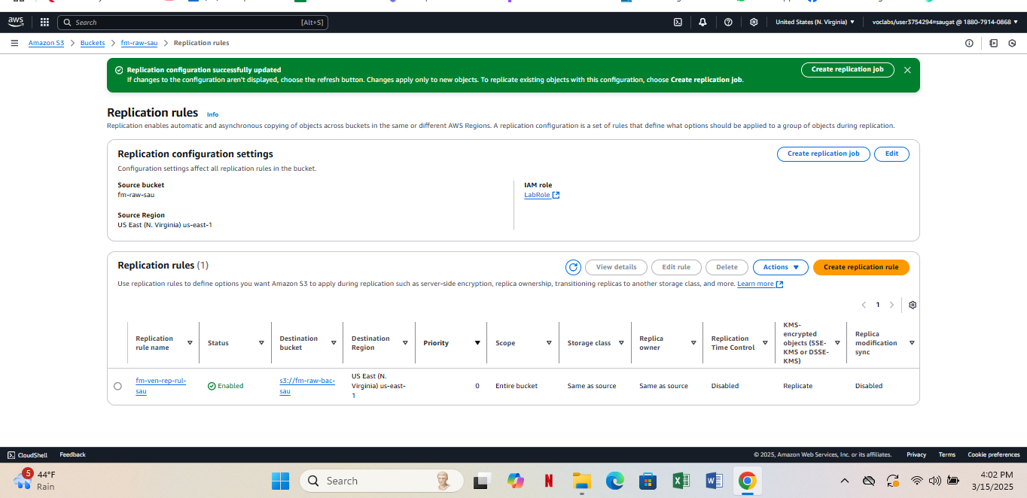

*Figure 9: Bucket Versioning and Default Encryption*

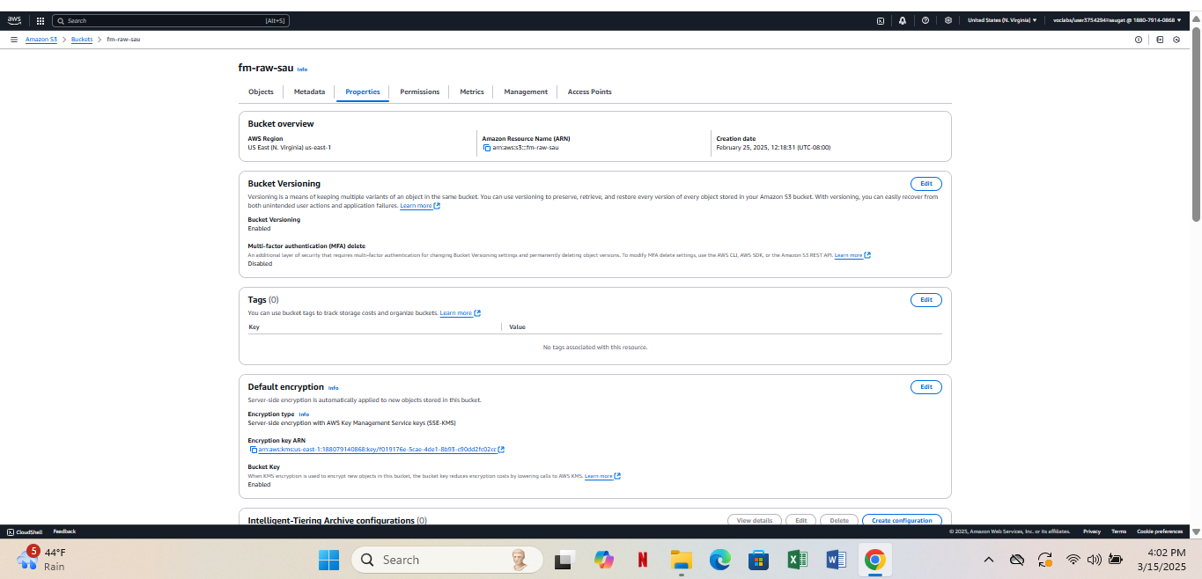

AWS implements data security measures for Vancouver community food market dataset storage which defends the information from unauthorized access and protects it from corruption and loss. The security procedures for data protection consist of Amazon S3 replication and encryption and AWS Key Management Service (KMS).

Amazon S3 replication enables the process through the creation of the replication rule (fm-ven-rep-rul). The system duplicates all data between the source bucket fm-raw-sau to the destination bucket fm-raw-bac-sau through automatic processes which protect data during system failures and accidental deletions. The replication takes place in the US East-1 region while AWS KMS (SSE-KMS) handles data encryption as objects transfer between locations. The source bucket gains protection by having its versioning features activated as part of the security measures. The versioning capability protects different versions of files from accidental deletion or accidental overwrites. The implementation of MFA delete disables its functionality which ensures that data deletions remain accessible through role-based access policies.

Security is improved through the implementation of default encryption from AWS KMS for the bucket. The system operates with an fm-ven-key-sau managed by customers through AWS Key Management Service (KMS) to execute encryption along with decryption processes. Data encryption happens automatically when it rests so authorized users who hold decryption privileges remain its only accessible entity. The complete security solution incorporates S3 replication for backup alongside bucket versioning for recovery in addition to using KMS encryption which maintains accessibility of protected sensitive market data. An effective data security framework emerges due to these protective measures that defend both unauthorized access and data modifications and accidental losses.

## Step 7: Data Governance:

*Figure 10: ETL Job for Vancouver Food Market and Farmers Market*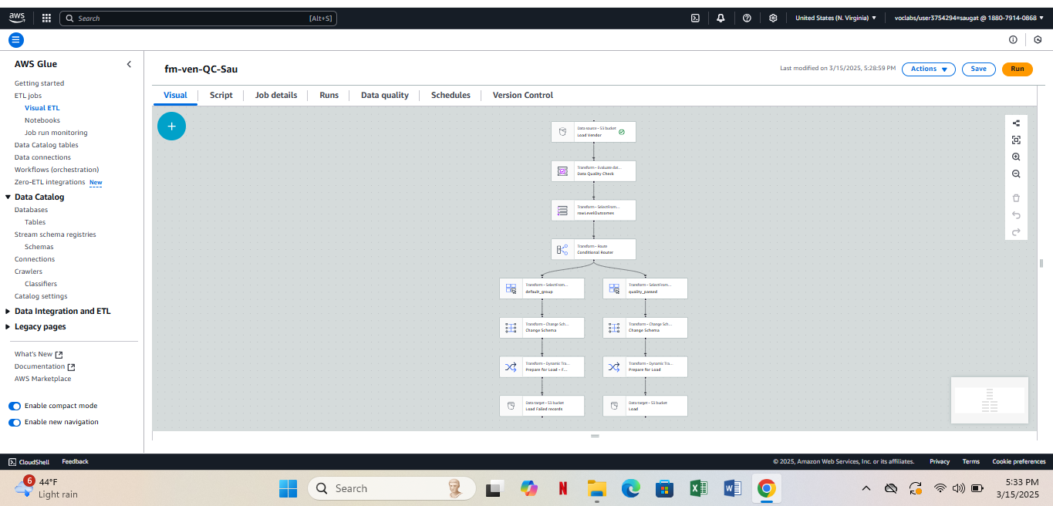

*Figure 11: Quality Check for passed dataset*

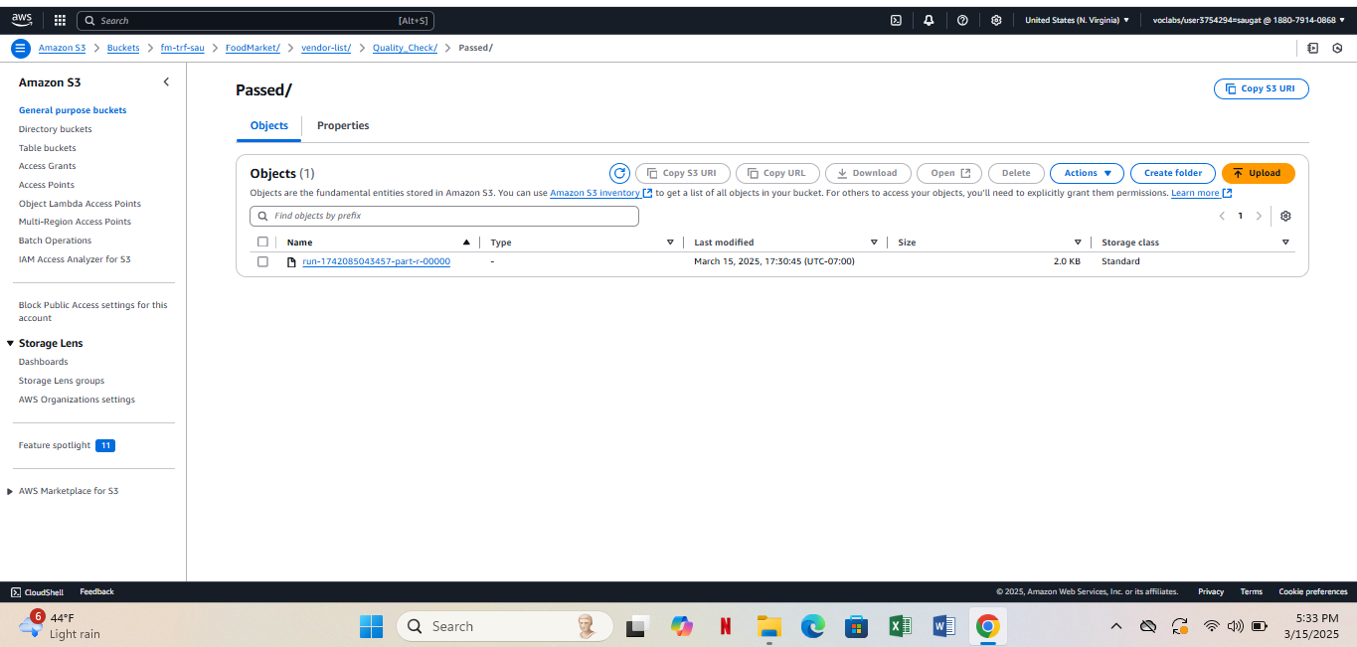

*Figure 12: Quality check for failed dataset*

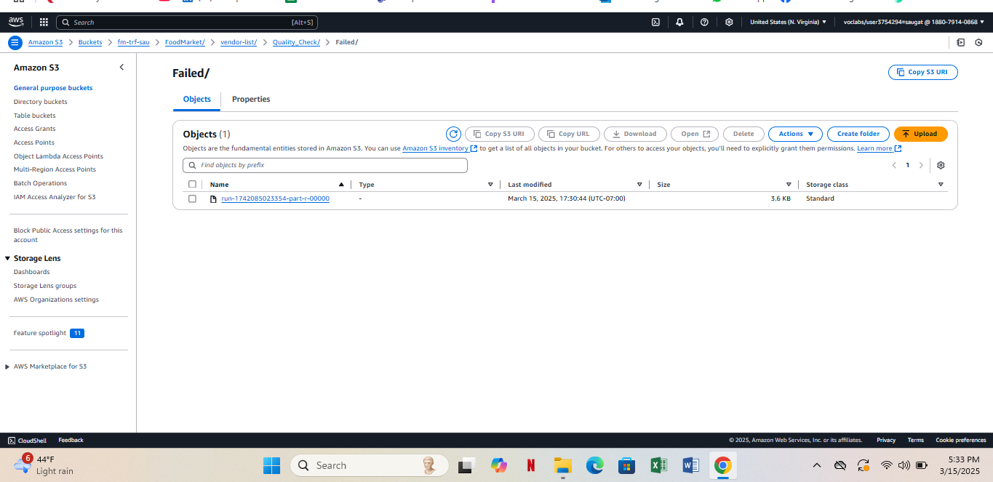

A data quality and validation process of the Vancouver community food market dataset ensured the selection of accurate and complete records for further analysis. The dataset was split into "Passed" markets and "Failed" markets during evaluation through established criteria. The database included Passed markets which satisfied all quality criteria including completeness, correctness and consistency. The Vancouver Farmers Market - Trout Lake along with the Kitsilano Farmers Market, Granville Island Public Market, Main Street Farmers Market, Mt. Pleasant Farmers Market, False Creek Farmers Market and East Vancouver Farmers Market and Downtown Farmers Market make up the markets analyzed.

The evaluation showed Failed to ensure data accuracy status for markets which presented missing information combined with inconsistent or incorrect data content. The failed market segments consisted of the Riley Park Winter Farmers Market along with the West End Farmers Market and UBC Farmers Market as well as River District Farmers Market and Strathcona Farmers Market and GasTown Farmers Market and Yaletown Farmers Market and South Granville Farmers Market. The evidence classification system divides records into "Passed" and "Failed" sections to guarantee the use of dependable data in decision making and reporting processes.

Data validation and governance procedures function as vital elements because they protect data quality standards and prevent wrong insights and ensure proper integrity. Failed records need to be partitioned so organizations can perform data improvement procedures before the records get reintroduced to the dataset. An organized methodology enables businesses to achieve data reliability which helps in urban planning alongside forecasting and business intelligence for community food markets.

## Step 8: Data Monitoring:

*Figure 13: Cloud Watch*

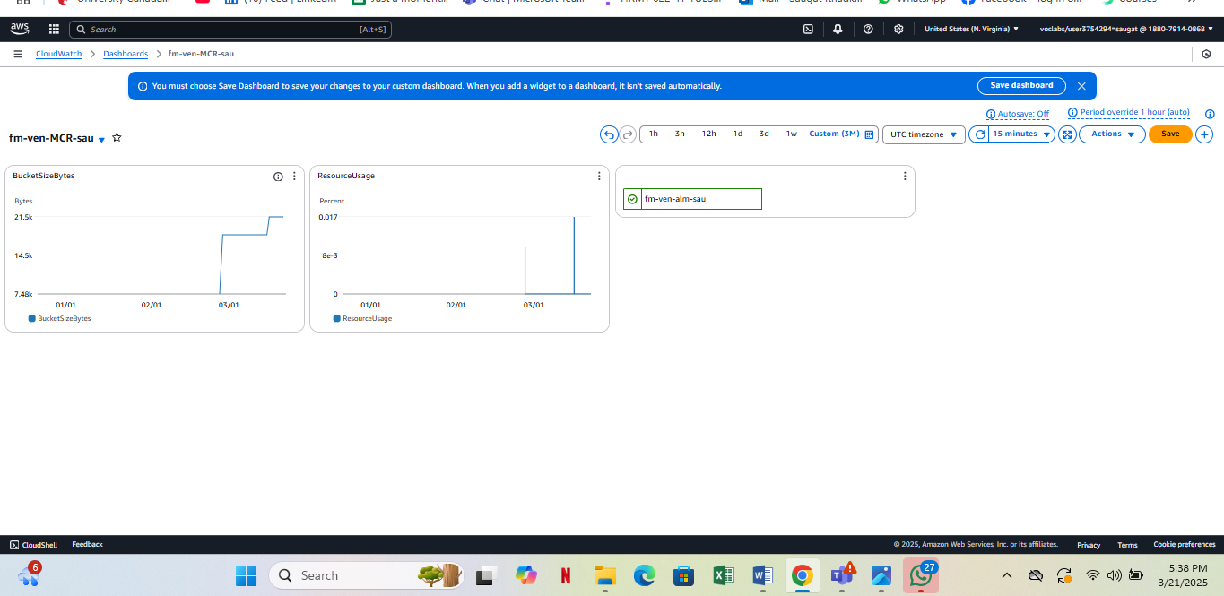

*Figure 14: Cloud Trail*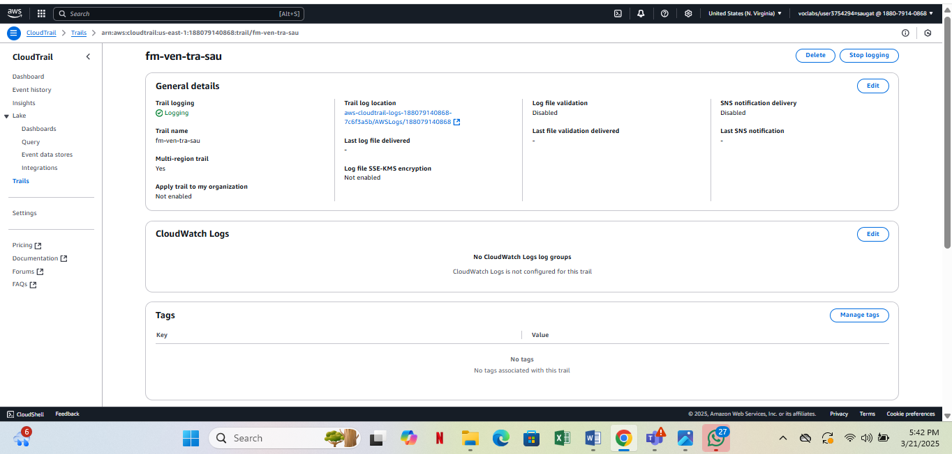

The Vancouver community food market dataset requires data monitoring for obvious operational visibility together with performance tracking and activity log auditing. AWS delivers Amazon CloudWatch and AWS CloudTrail as built-in solutions to enable thorough monitoring of data and infrastructure tracking capabilities. The monitoring configuration in Amazon CloudWatch checks bucket storage size and resource usage metrics through screenshots. The S3 buckets related to food market dataset storage volume can be tracked through this system which reveals both data growth patterns and irregular usages. The metrics provide valuable information for resource planning because they help supervise storage and compute resource efficiency. A sudden increase in bucket size indicates that the system is receiving greater amounts of data possibly through new market participation or larger vendor upload activities.

The AWS CloudTrail system operates with its trail named fm-ven-tra-sau which is currently in active mode. The tool functions as an audit system by recording every single API event interaction and user activity within AWS services. AWS CloudTrail functions as an audit log system which makes records of user identity timestamps and executed activities in the dataset. Transparency at this level serves security needs along with compliance requirements as well as auditing requirements. Arrow offers log file encryption and validation capabilities but the system currently has those services disabled and the logging function provides full monitoring capabilities for detecting unauthorized actions. CloudTrail functions as the logging system in the background even without CloudWatch Logging configuration for this trail record.

All deployed tools create a comprehensive system for monitoring the food market dataset. CloudWatch grants access to usage patterns but CloudTrail produces an activity audit trail that ensures security. The monitoring system verifies that dataset users maintain proper behavior while utilizing system resources to maximum effect as it detects any abnormal activities in real-time.

# DAP Implementation: Team Member 3 # Shwetha Mohankumar (Council Voting Record dataset)

## Design to implement

**Figure 1.1**

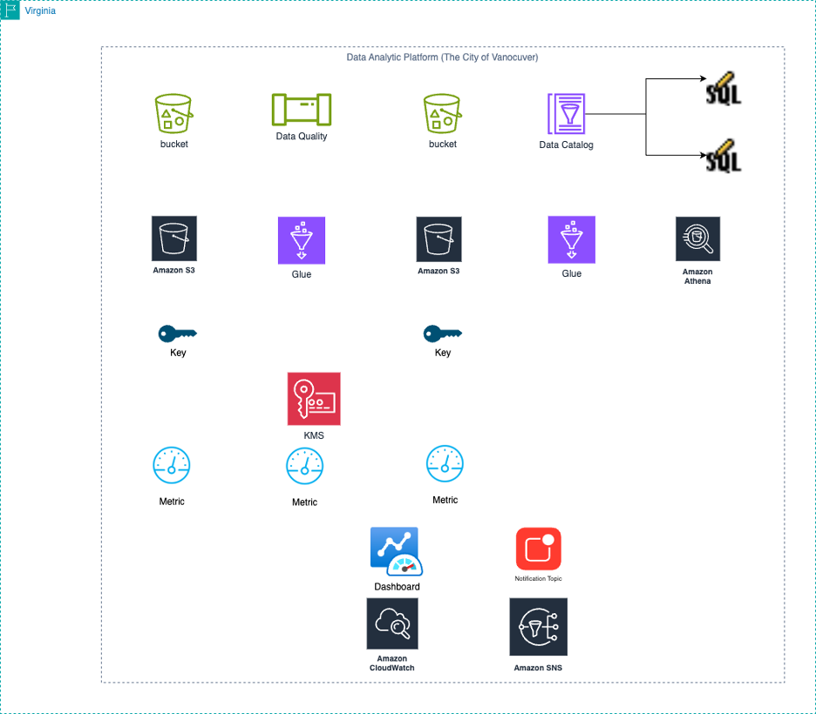

***Note.*** This is a predefined structure, which has been provided to implement the next 4 phases of the project.

The following is architecture diagram of a complete AWS based Data Analytics Platform for City of Vancouver. The solution leverages different cloud native service to create a secure, scalable and automated data pipeline. Raw and processed data are stored in two different Amazon S3 buckets at the top level, which enables them to be separated from each other. These buckets are fed by a data quality component, which filters records as it is predefined. Data Catalog is where AWS Glue metadata is stored, and AWS Glue ETL job transforms and validates the data for writing back to S3. This structured data can be queried in a fast, serverless analytics, with no infrastructure to manage, using SQL with Amazon Athena.

This architecture inherently includes all elements security and monitoring. Both AWS KMS and customer-managed keys are used for encryption of data at rest so that the data is secure and the compliance is addressed. Amazon CloudWatch tracks operational metrics and logs, and the bucket size and resource usage and performance of the dashboards is also displayed. With notification topics, communication with stakeholders in case of a failure or an anomaly can be done proactively, with Amazon SNS. But when combined, this forms a well governed, cost effective and fully managed data platform suitable for the use cases such as city governance, infrastructure planning, public service analytics.

## Step 5: DATA ANALYSIS

**Figure 1.2**

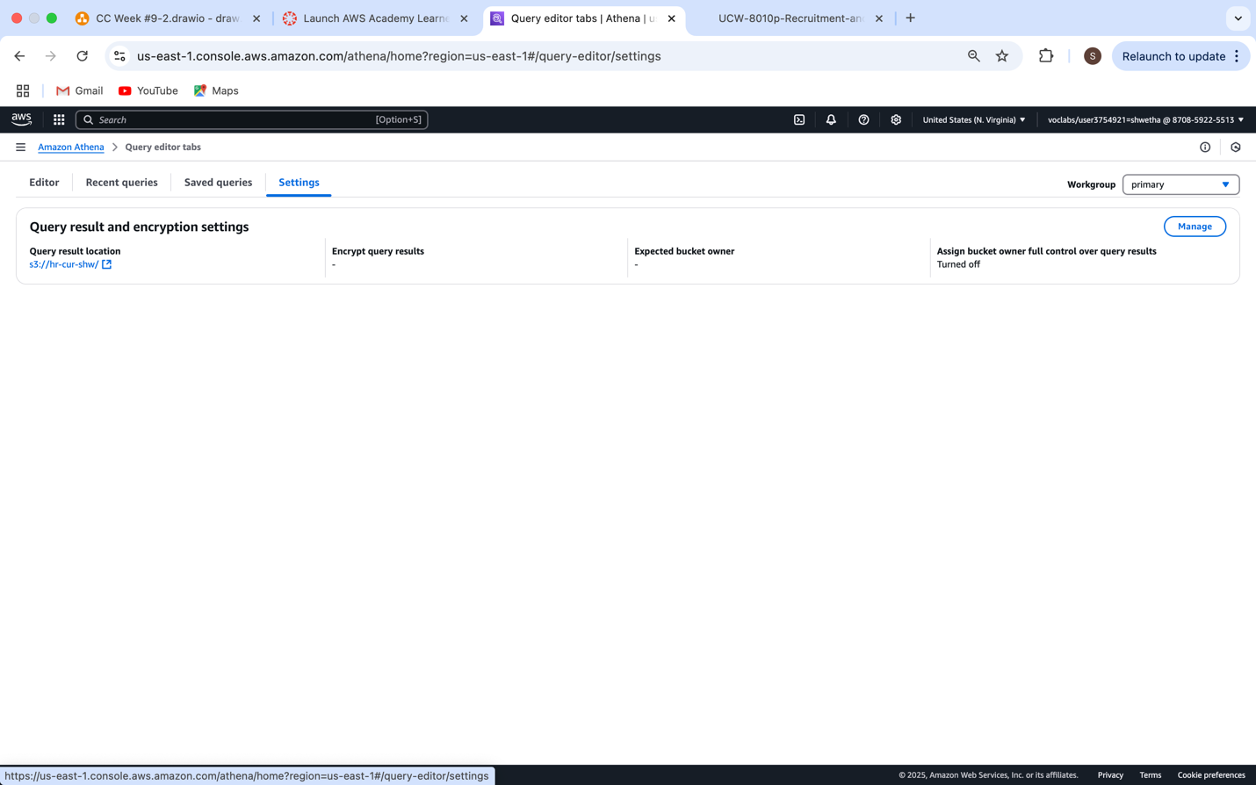

Amazon Athena presents the Query result and encryption settings in the Settings tab which appears under Query editor tabs. This monitor between us follows DAP implementation as explained in your report before showing the selection of Query result location as 's3://hr-cur-shw/'. The Athena query result path setup follows the standard procedure that all team members implemented to store their SQL query outputs into structured form in the S3 storage system. The data analysis framework of Athena works optimally because this setup creates both an easy workflow and accessible results storage for later use or visual representation. The interface indicates a need for encryption through AWS KMS alongside bucket policies which developers should implement subsequently due to the repeated security references in this document.

**Figure 1.3**

*Query and the output for finding the insights*

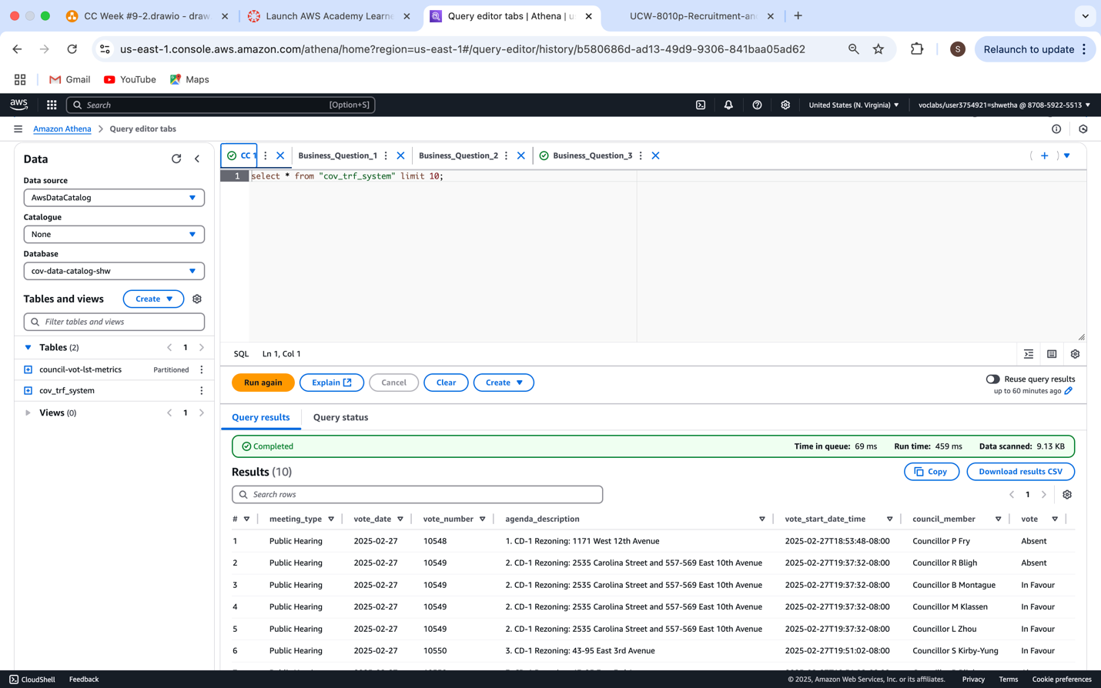

This screenshot shows an Athena query selecting 10 rows from `cov_trf_system`, displaying council meeting voting data in tabular form.

**Figure 1.4**

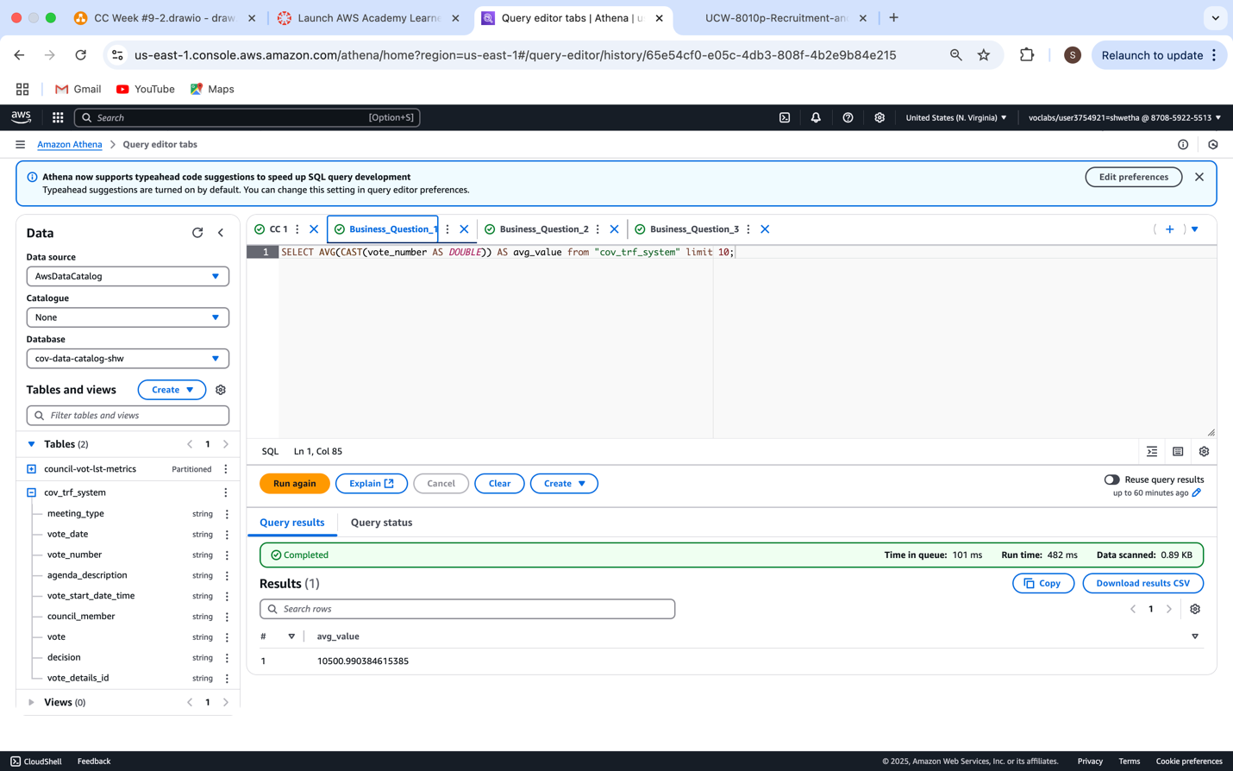

**Query 1:** This query calculates the average of the vote_number column by casting its values as double precision numbers. It helps understand the general voting trend across council meetings by summarizing vote counts from the dataset cov_trf_system. The result shows one aggregate value: the average vote number.

**Figure 1.5**

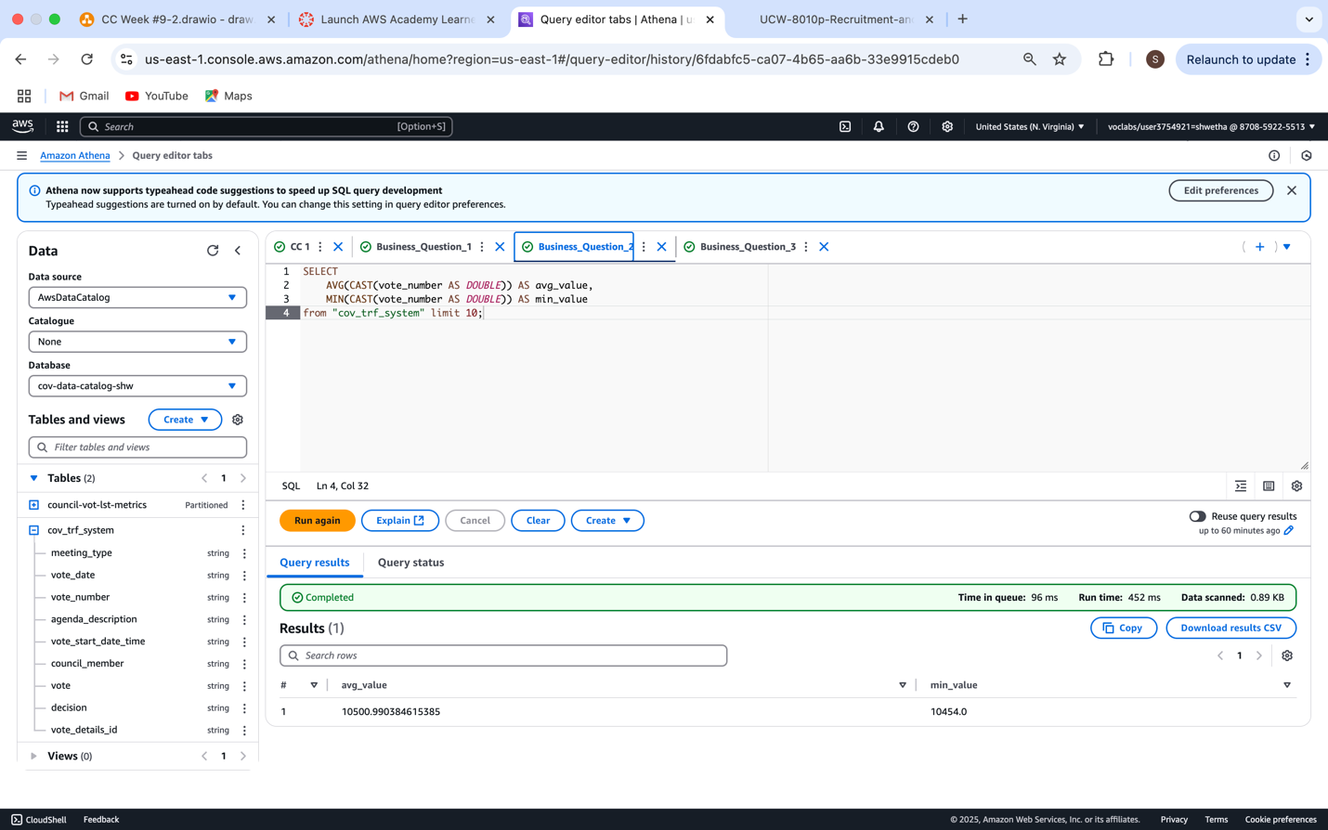

**Query 2:** This query calculates both the average and minimum values of the vote_number field. By casting it as DOUBLE, it ensures numerical operations are accurate. The results help summarize voting trends by identifying the overall average and the smallest vote count recorded in the dataset for council meetings.

**Figure 1.6**

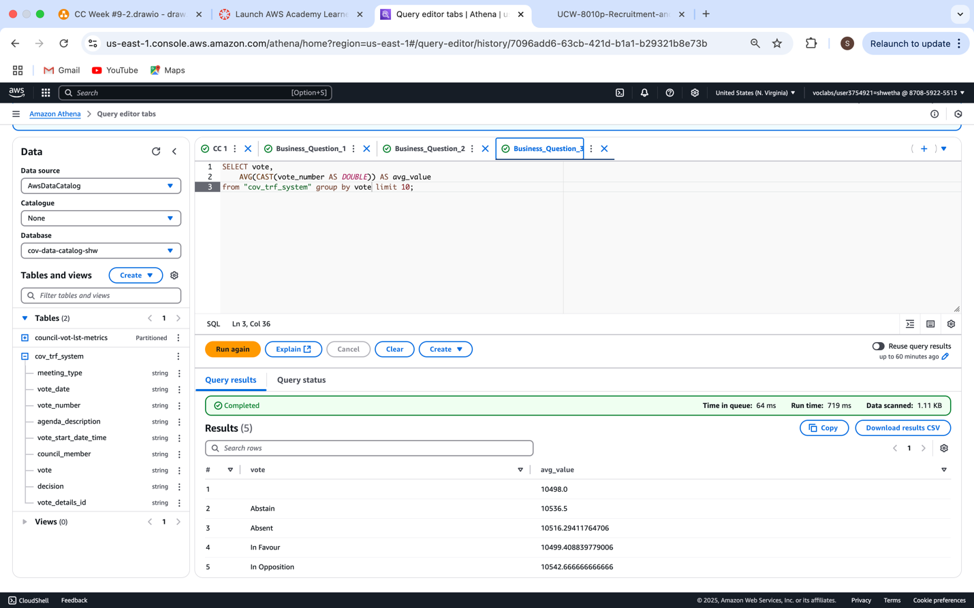

**Query 3:** This query groups records by the vote type (e.g., In Favour, Opposed, Abstain) and calculates the average vote number for each group. It helps analyse voting behaviour trends by category, revealing which voting decisions are associated with higher or lower average participation in council meetings.

## STEP 6: DATA SECURITY

**Figure 1.7**

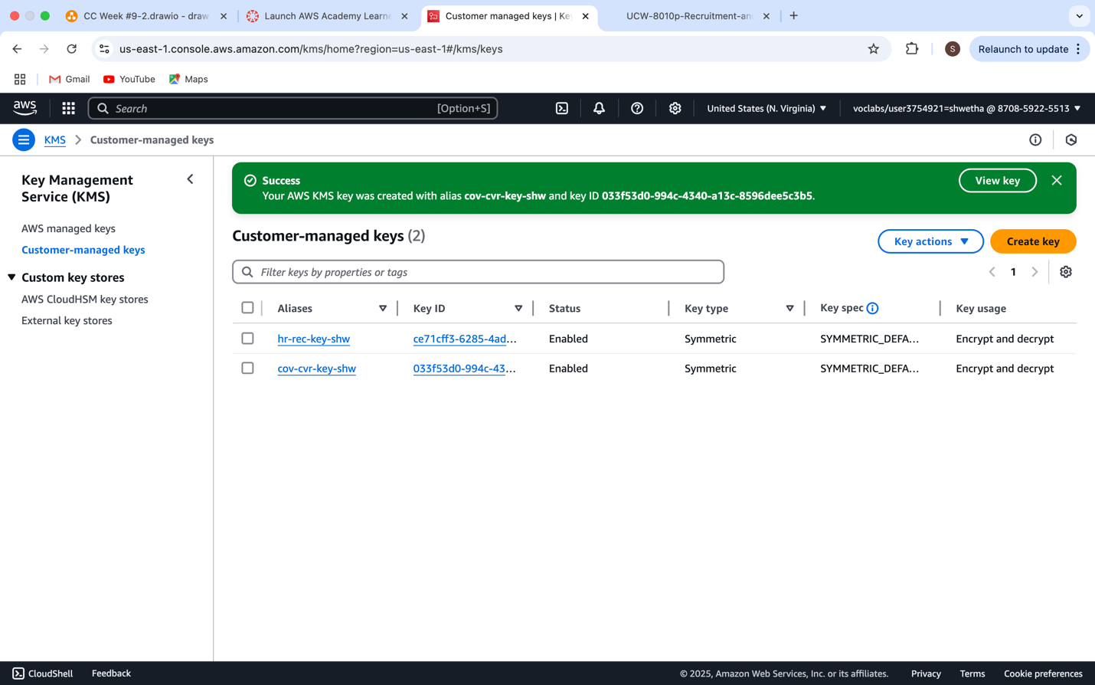

This is from the AWS Key Management Service (KMS) console shows the successful creation of a customer-managed encryption key with the alias `cov-cvr-key-shw`. Customer-managed keys are a core part of data security in AWS, allowing users to control, define and audit encryption keys used to protect sensitive data.

Here, the key listed - `cov-cvr-key-shw`

The above are symmetric keys, meaning the same key is used for both encryption and decryption, and their status is marked as Enabled, allowing them to be used immediately. The Key usage column confirms they are configured for "Encrypt and decrypt" operations, aligning with AWS security best practices for ensuring data confidentiality and integrity in services like Amazon S3, Athena, and Glue.

This setup enables fine-grained access control and auditing capabilities, critical for protecting data in a cloud analytics pipeline, especially when handling sensitive datasets like council voting records.

**Figure 1.8**

*Assigning keys to S3 raw bucket by changing ‘Default Encryption’*

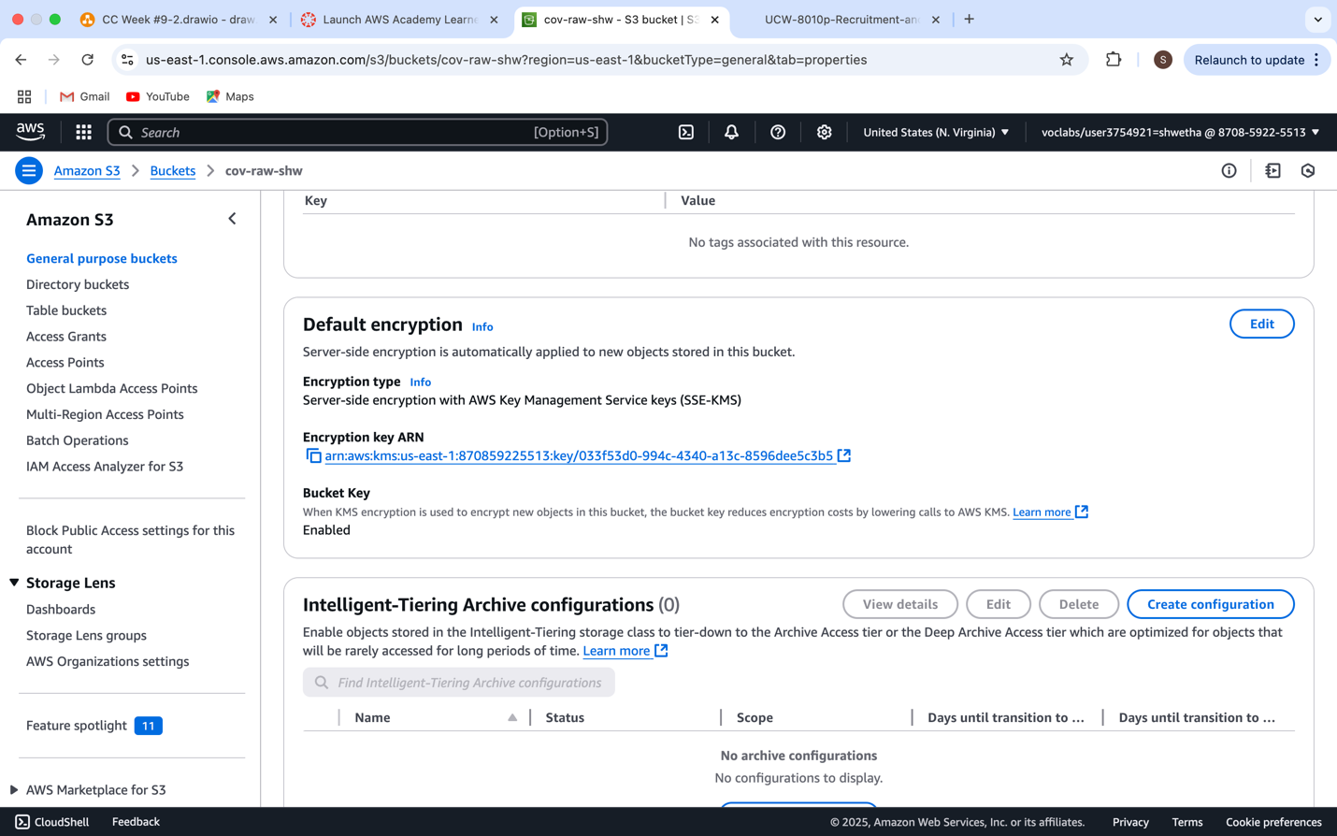

This shows the "Default encryption" settings enabled for the S3 bucket cov-raw-shw in AWS. This configuration applies server-side encryption with AWS Key Management Service (SSE-KMS) to all new objects stored in the bucket. The key used is a customer-managed key , which is the same key shown in the previous KMS screenshot (cov-cvr-key-shw).

Key Highlights:

* Encryption Type: SSE-KMS – ensures data is encrypted at rest using a secure, auditable key.
* Encryption Key: Custom KMS key (user-defined, not AWS-managed).
* Bucket Key Enabled: This option reduces the cost of KMS encryption requests by using a single bucket-level key rather than calling KMS for each object.

Purpose: This setup guarantees confidentiality and compliance, ensuring that all data written to this bucket is automatically encrypted without requiring manual configuration for each object. It is a best practice for securing sensitive datasets in AWS cloud environments.

**Figure 1.9**

*Enables ‘Bucket Versioning’ in S3 raw bucket*

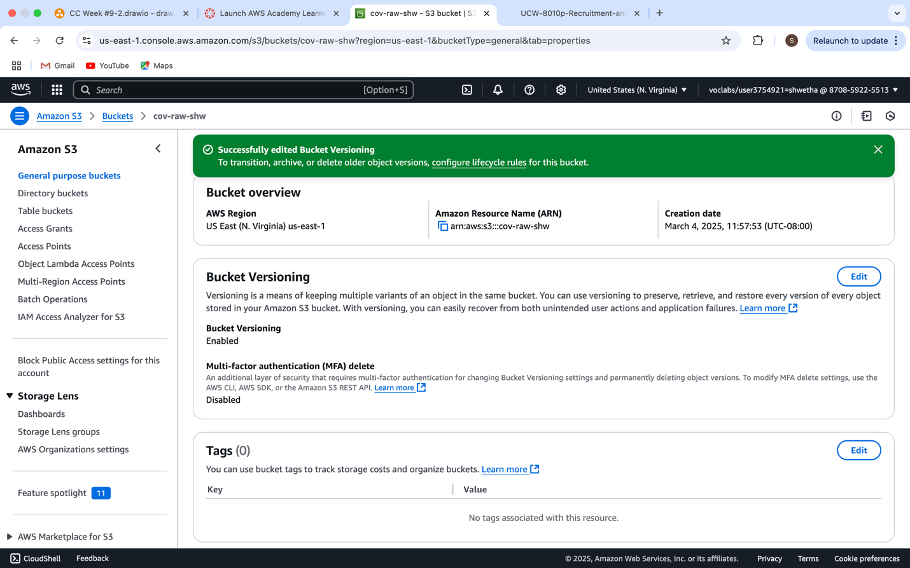

This shows the Bucket Versioning settings for the S3 bucket `cov-raw-shw` in AWS. Versioning is a powerful feature that allows multiple versions of the same object to be stored, providing protection against accidental deletions, overwrites, and system failures.

Key Elements:

- Bucket Versioning: Enabled

- Multi-Factor Authentication (MFA) Delete: Disabled

MFA Delete adds another layer of protection by requiring MFA authentication to delete objects or change versioning settings. It is currently disabled, which could be a future improvement for stricter data security.

- Confirmation Banner:

The green success message indicates that bucket versioning has been successfully enabled.

Purpose:

Enabling versioning aligns with AWS best practices for data protection and integrity, particularly in analytics projects where preserving original and modified data is crucial for compliance, rollback, and audit trails.

**Figure 1.10**

*Replication rule in S3 raw bucket*

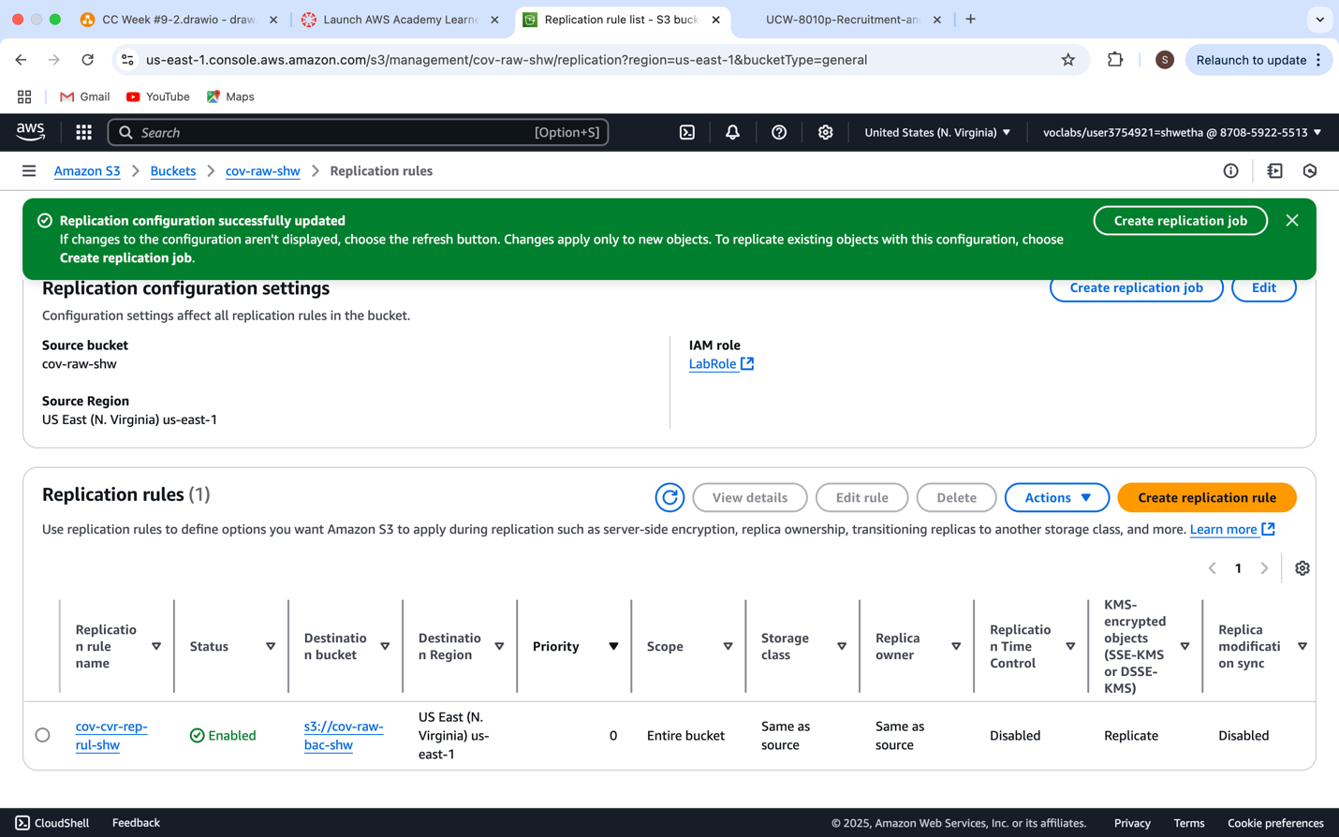

This shows the Replication configuration page for the S3 bucket cov-raw-shw in AWS.

Key Details:

* Replication Rule Name: cov-cvr-rep-rul-shw
* Status: Enabled – the rule is active and functioning.
* Source Bucket: cov-raw-shw
* Destination Bucket: cov-raw-bac-shw
* Destination Region: Same as source (US East - N. Virginia)
* IAM Role: LabRole – used to grant permissions required for replication.
* Scope: Entire bucket – all objects in the source bucket will be considered.
* KMS-encrypted objects: The rule supports replication of SSE-KMS-encrypted data, ensuring even encrypted files are securely copied.

Purpose:

This setup enables automated and secure cross-bucket replication for business continuity, backup, and compliance needs. It ensures that even if data in the source bucket is lost or corrupted, a synchronized backup exists in the destination bucket.

**Figure 1.11**

*Assigning keys to S3 raw bucket by changing ‘Default Encryption’*

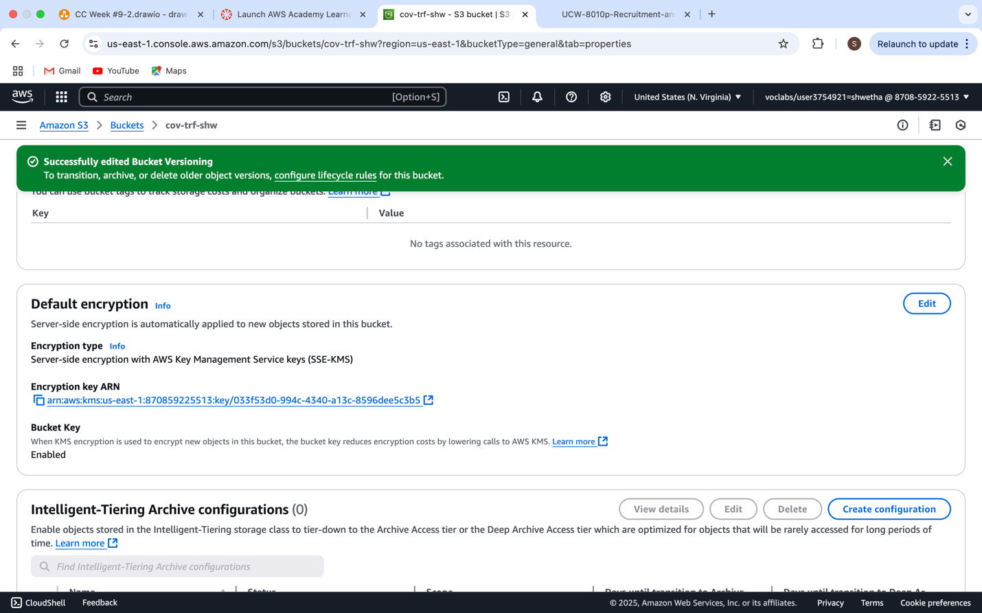

The Same procedure for the cov-trf-shw.

**Figure 1.12**

*Enables ‘Bucket Versioning’ in S3 raw bucket*

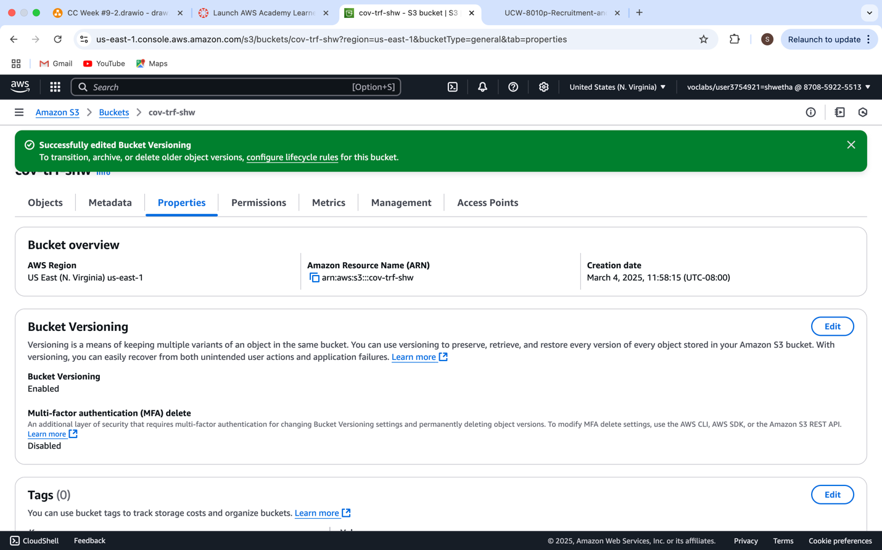

**Figure 1.13**

*Replication rule in S3 raw bucket*

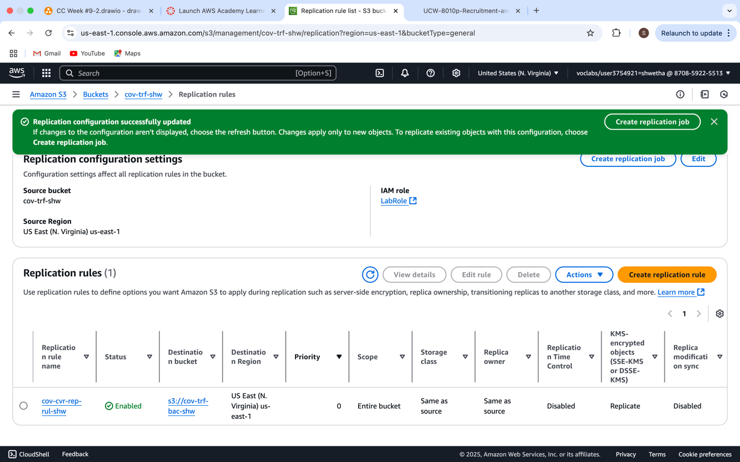

**Figure 1.14**

*Assigning keys to S3 raw bucket by changing ‘Default Encryption’*

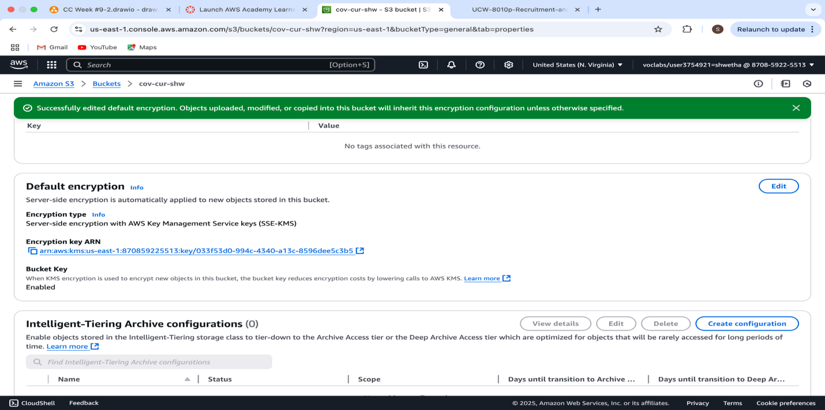

**Figure 1.15**

*Enables ‘Bucket Versioning’ in S3 raw bucket*

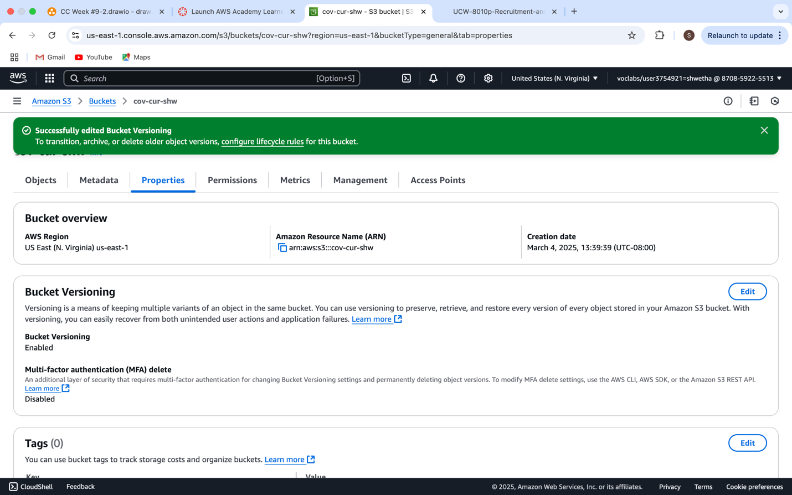

**Figure 1.16**

*Replication rule in S3 raw bucket*

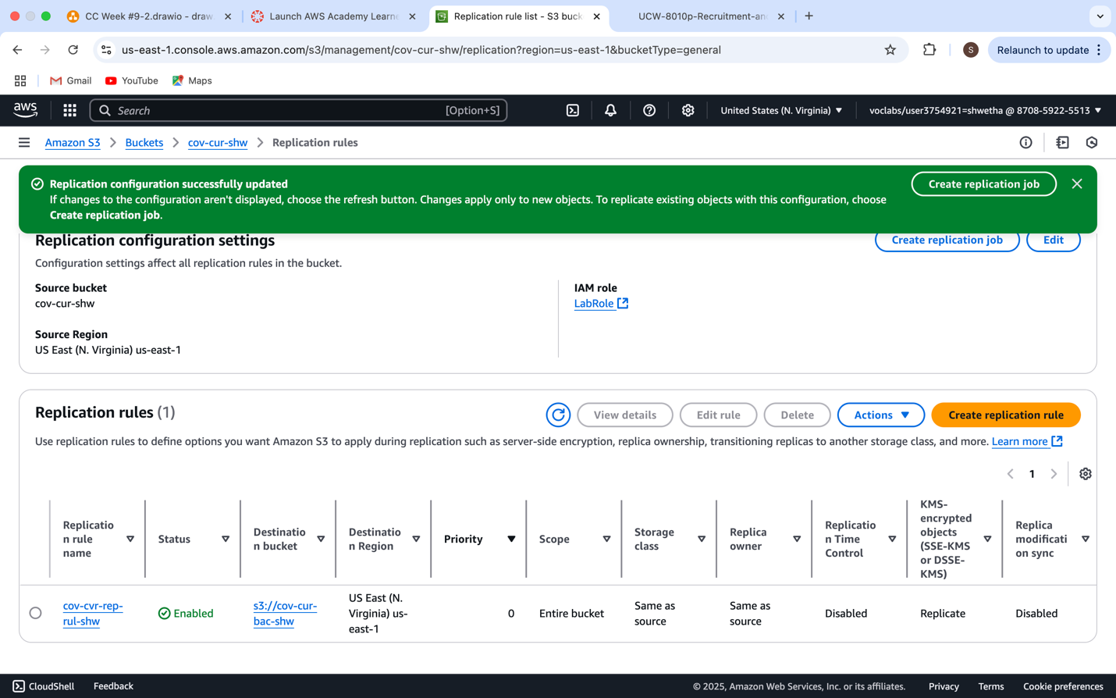

## STEP 7 - DATA GOVERNANCE:

Failed**-**

**Figure 1.17**

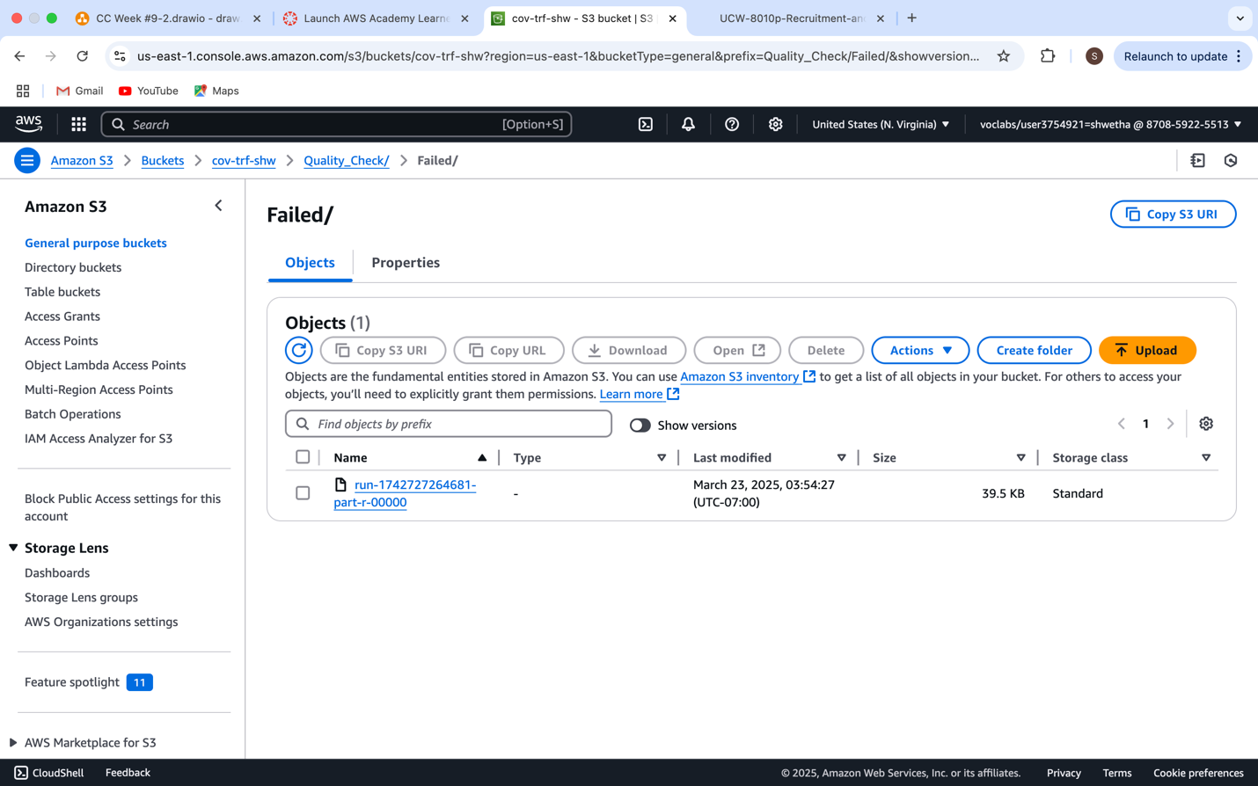

It reflects a **Data Governance** implementation using AWS S3, specifically showing the Failed folder under the Quality_Check directory within the bucket cov-trf-shw.

This file was automatically generated through a data quality check pipeline, likely built using AWS Glue Visual ETL. The Failed folder is used to segregate records that did not meet predefined data quality rules—such as completeness, uniqueness, or value thresholds.

Purpose in Data Governance:

* Transparency: Isolating failed records ensures bad data doesn’t contaminate clean datasets.
* Auditability: Helps track and reprocess problematic data entries.
* Compliance: Enforces governance standards by separating data based on quality outcomes.
* Automation: This structure supports automated data validation and classification as part of a scalable governance framework.

This is a best practice in AWS-based data lakes to maintain data accuracy, trustworthiness, and integrity throughout the analytics lifecycle.

**Passed-**

**Figure 1.18**

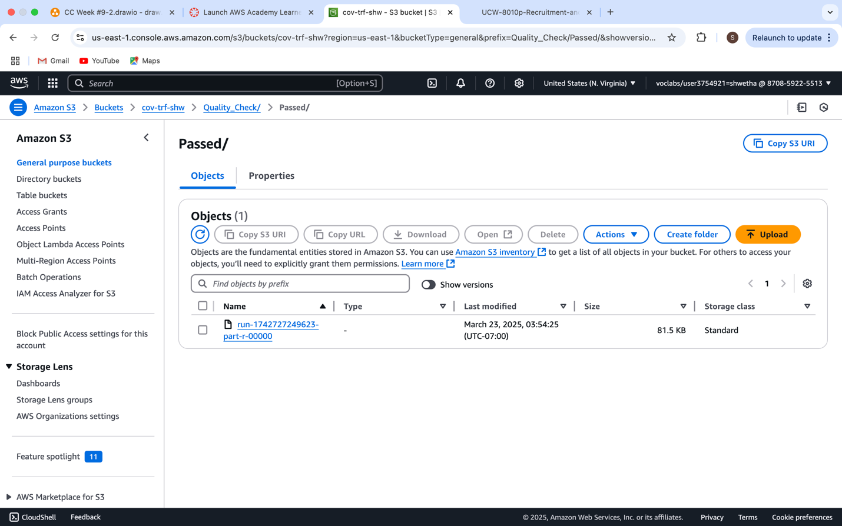

This shows the **"Passed"** folder inside the Quality_Check directory of the S3 bucket cov-trf-shw, representing successful data governance and validation.

This object contains **records that passed the quality check** defined in an AWS Glue ETL pipeline. These records met all predefined rules—such as required fields being complete, unique values being maintained, valid data types, and logical consistency.

**Figure 1.19**

*Visual ETL Pipeline for quality check*

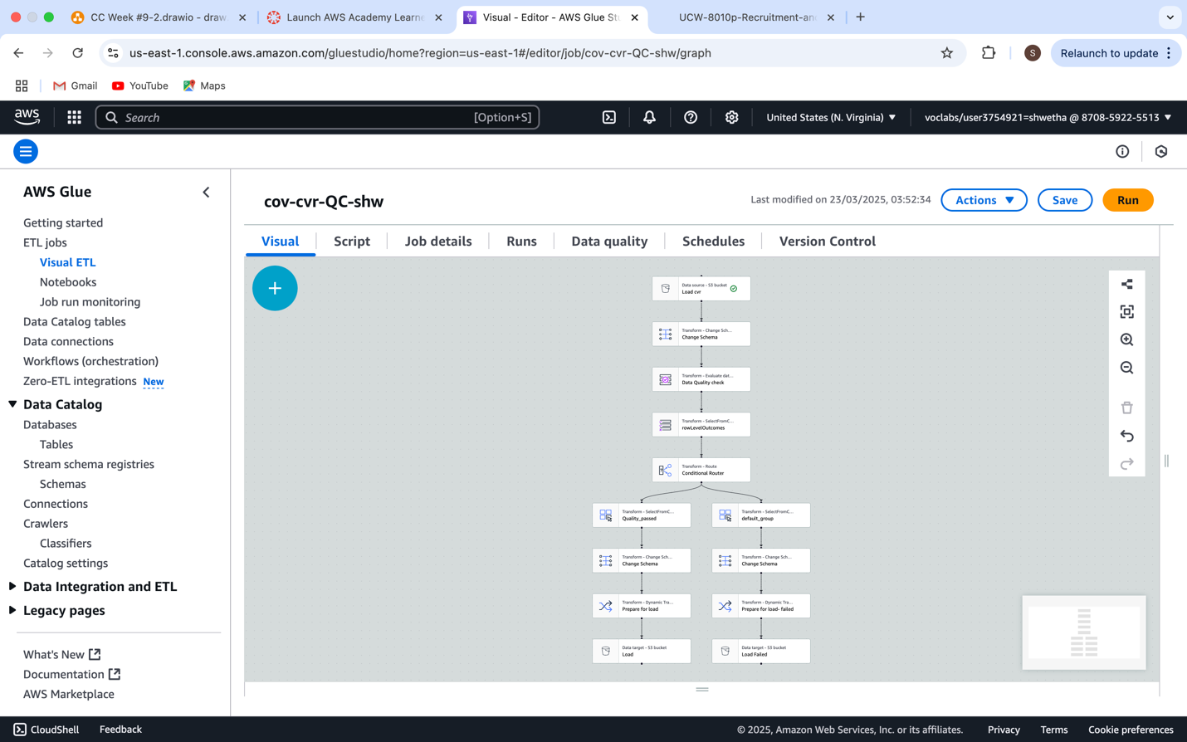

This displays an **AWS Glue Visual ETL Job** interface titled cov-cvr-QC-shw, representing a complete **ETL (Extract, Transform, Load) data pipeline** built using **AWS Glue Studio**. It visually outlines each step of the job used to process, validate, and categorize data, likely related to council voting records

**Source Node (Topmost Block):**

* Source: cov-trf-shw (S3)
* This is the starting point of the pipeline where raw data is ingested from an Amazon S3 bucket.

**Data Transformation Nodes (Middle Layer):**

* **Schema Detection and Casting:** Raw data is converted into a structured format, and data types are cast properly.
* **Data Quality Rules:** Custom rules are applied to check for completeness, validity, uniqueness, and logical consistency.
* **Conditional Splitter:** This component is critical—it separates the data into two branches based on the quality checks:
  + Passed Data
  + Failed Data

**Sink Nodes (Bottom Layer):**

* These nodes represent the output destinations:
  + The Passed records are written to the Quality_Check/Passed/ folder in S3.
  + The Failed records go to the Quality_Check/Failed/ folder.
* Each output is saved in Amazon S3, likely in Parquet or CSV format, and stored under appropriate storage classes for cost efficiency.

## STEP 8 - Data Monitoring

Data monitoring dashboard in AWS CloudWatch

**Figure 1.20**

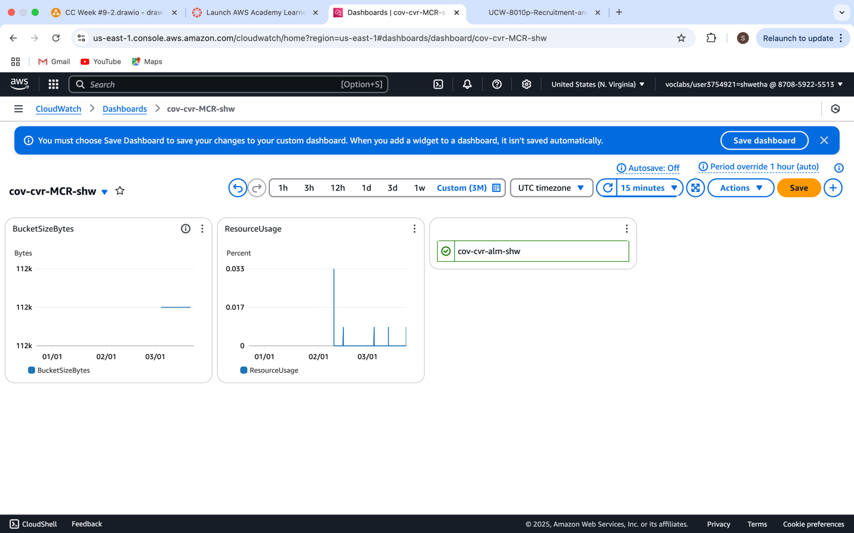

This displays a **custom CloudWatch Dashboard** named cov-cvr-MCR-shw, used for **data monitoring** in AWS. It visually tracks the health, size, and usage of S3 buckets or other AWS resources in near real-time, which is essential for managing data lakes and ETL pipelines effectively.

**Purpose in Data Monitoring:**

This dashboard enables:

* Proactive alerts if resource thresholds are breached.
* Capacity planning for storage and performance.
* Real-timevisibility into how data and processes are evolving.
* Accountability and audit readiness for governance and reporting.

**Figure 1.21**

CloudTrail user activities log

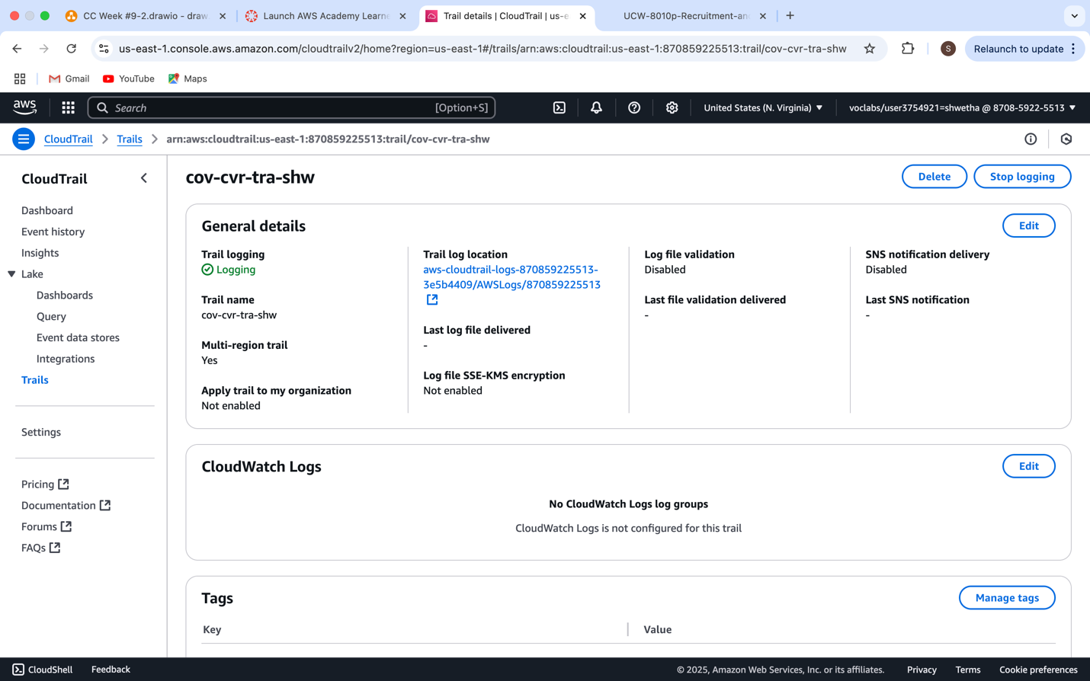

This screenshot shows the **AWS CloudTrail configuration** for the trail named cov-cvr-tra-shw, which is a key part of **security and compliance auditing** within AWS.

# DAP Implementation: Team Member 1# Juhi Ali (Operation Management dataset)

## Step 5: Data Analysis

*Figure 1 Amazon S3 Bucket – system/ Folder*

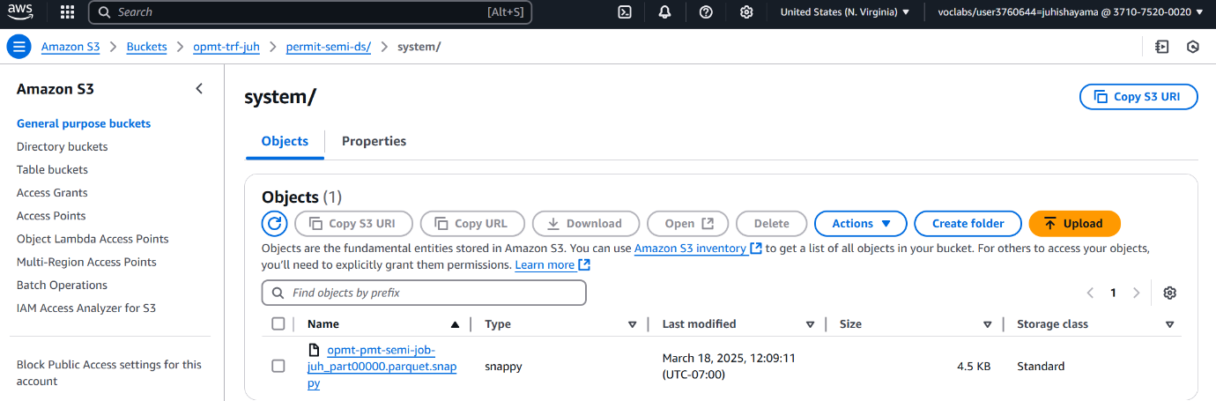

The screenshot provides details about the contents which exist within the system/ directory located inside the Amazon S3 bucket opmt-trf-juh/permit-semi-ds/. The folder contains the Parquet format intermediate data file opmt-pmt-semi-job-juh_part00000.parquet.snappy that uses Snappy compression. The folder exists to keep core information produced during data transformation operations. The system chooses Parquet format because it delivers optimized performance through efficient data storage along with quick read/write functionalities especially useful for large datasets. A transformation within an AWS Glue job most likely generated this file which serves as an internal working product instead of being designed for end-user access.

*Figure 2 Amazon S3 – user/ Folder*

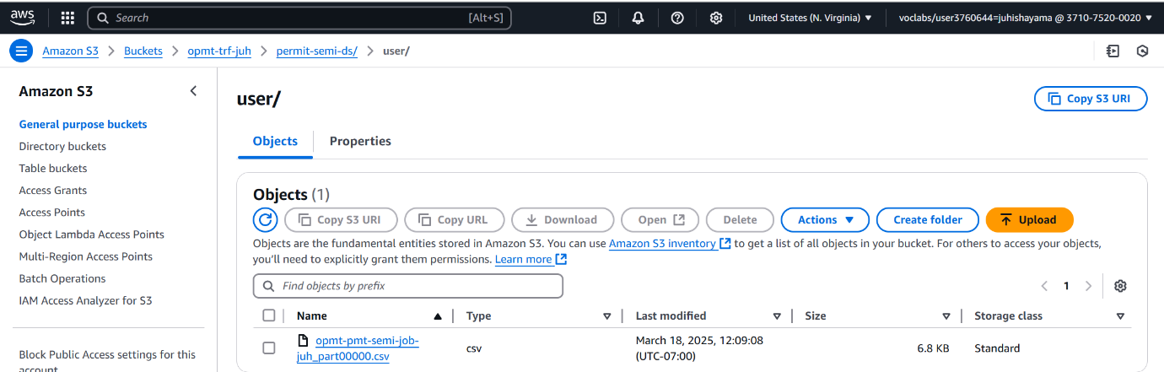

The second screenshot shows the user/ folder that exists inside the same Amazon S3 bucket. Inside the user/ folder, there is one CSV format file named opmt-pmt-semi-job-juh_part00000.csv. The user/ folder exists to store accessible output files that external systems together with users can easily read. The CSV format finds broad support from different tools and platforms including Excel and business intelligence tools so it becomes optimal when sharing and reporting output data. Stakeholders or downstream tools embrace this file because it marks the completed ETL process output which underwent validation and cleaning procedures.

Figure 3

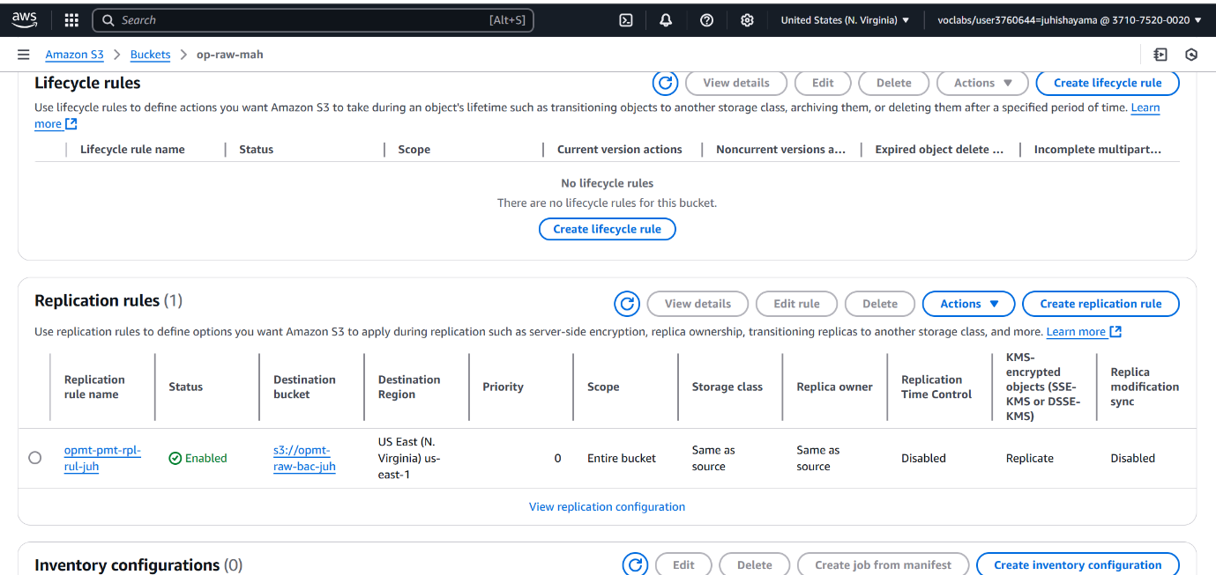

This screenshot shows the **Amazon S3 bucket settings** for lifecycle rules and replication rules. The **Lifecycle Rules** section is empty, meaning no rules are defined for transitioning or deleting objects over time. The **Replication Rules** section has one active rule named "opmt-pmt-rpl-rul-juh," which replicates data to the destination bucket "opmt-raw-bac-juh" in the **US East (N. Virginia) region**. The replication covers the entire bucket, retains the same storage class, and supports KMS-encrypted objects but has **replication time control disabled**.

## Step 6: Data Security

*Figure 4 AWS Key Management Service (KMS)*

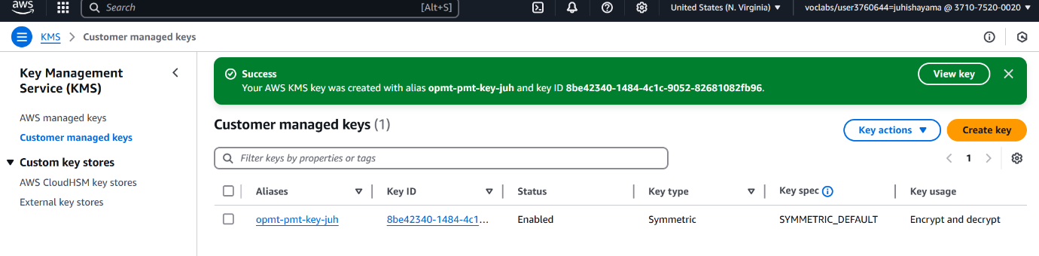

AWS Key Management Service (KMS) displays a customer-managed key with the alias opmt-pmt-key-juh which has been enabled under the SYMMETRIC_DEFAULT specification. The key function can perform encryption and decryption operations because it is enabled with the SYMMETRIC_DEFAULT specification. This security feature protects encryption of Amazon S3 data when it rests on storage and moves through the transit. Controlling encryption policies and key rotation as well as access permissions becomes better through the implementation of a customer-managed key instead of AWS-managed key access. Organizations need to establish this step for protecting their data through standards along with regulatory and internal policies.

Figure5 - AWS Glue Studio Job – Opmt-pmt-QC-juh

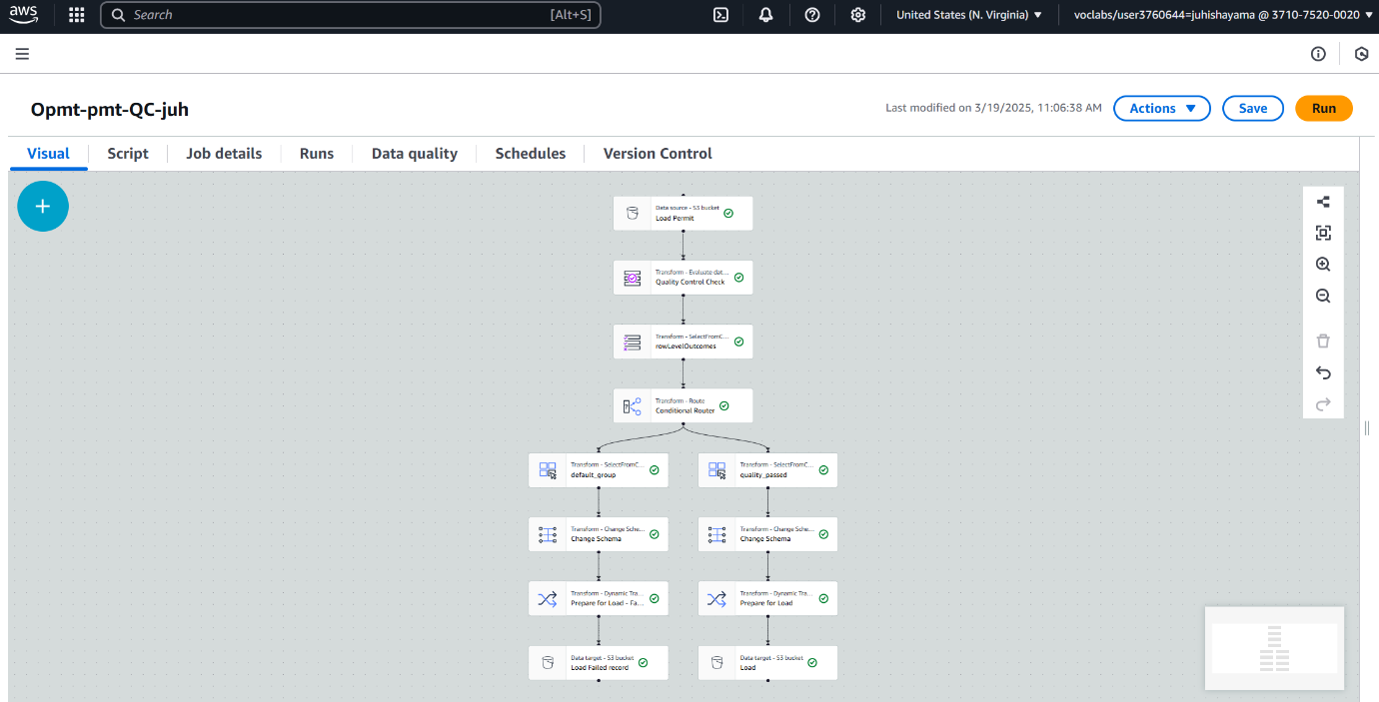

The final image visually represents an AWS Glue Studio job called Opmt-pmt-QC-juh. The job uses automation to control ETL through a visual design of data transformations alongside quality control assessments. The workflow begins by loading initial raw input data, followed by an instantaneous quality control process to validate the information. This validation outcome determines how a conditional router sends the data along specific routes. The data that successfully passes the quality check follows multiple operational sequences that begin with schema mapping and end with writing to the S3 location after preparing the output. Every transformation step in the job constitutes a dedicated operation which includes field selection and column renaming and data formatting. The designed pipeline routes high-quality information solely to storage environments which results in an ETL process that proves both scalable and reliable and operationally efficient.

## Step 7: Data Governance

Figure 6 AWS Glue DataBrew – Recipe Job Execution

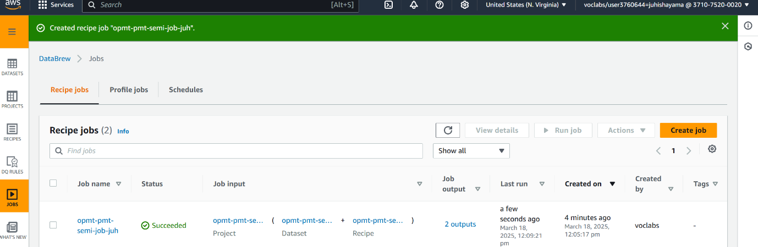

The displayed screenshot captures the successful completion of the DataBrew recipe job with name opmt-pmt-semi-job-juh. The implementation uses AWS Glue DataBrew for graphic data preparation that requires no programming. The “recipe” contains pre-defined transformation steps which this recipe job automatically applies to a dataset. After processing raw data input the job executes cleaning steps and formatting operations and validation rules and outputs the transformed data files according to specified data formats (CSV, Parquet and so on). When properly implemented the job stands to provide consistent automated data preparation before analytics work or machine learning applications.

*Figure 7 Amazon S3 – op-raw-juh Bucket Properties*

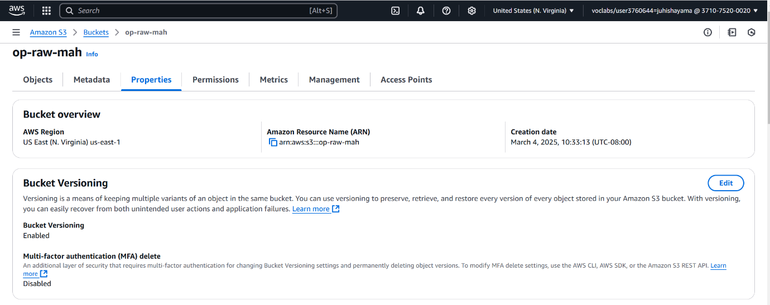

The displayed screenshot captures the successful completion of the DataBrew recipe job with name opmt-pmt-semi-job-juh. The implementation uses AWS Glue DataBrew for graphic data preparation that requires no programming. The “recipe” contains pre-defined transformation steps which this recipe job automatically applies to a dataset. After processing raw data input the job executes cleaning steps and formatting operations and validation rules and outputs the transformed data files according to specified data formats (CSV, Parquet and so on). When properly implemented the job stands to provide consistent automated data preparation before analytics work or machine learning applications.

*Figure 8 Amazon S3 – Default Encryption with KMS*

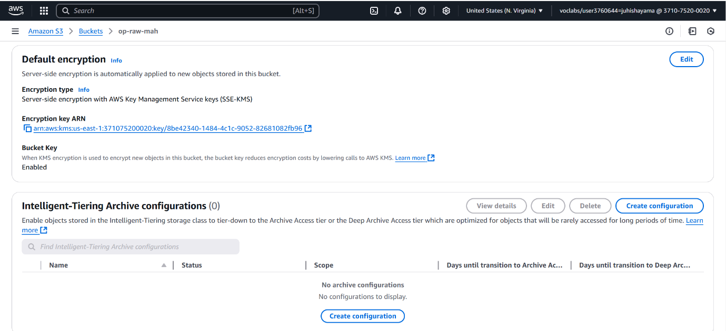

The screenshot presents the encryption settings of the exact same op-raw-mah S3 bucket. An AWS KMS (SSE-KMS) server-side encryption protects this bucket through the application of a particular customer-managed key shown in your previous KMS screenshot. All added data in this bucket encrypts automatically at upload time through the default settings which follow both security and compliance requirements. The Bucket Key feature operates in parallel to decrease KMS request expenses during extensive data processing operations. Server-side encryption through AWS KMS (SSE-KMS) technology increases both data privacy and security elements.

*Figure 9 AWS Glue DataBrew Project – Data Exploration*

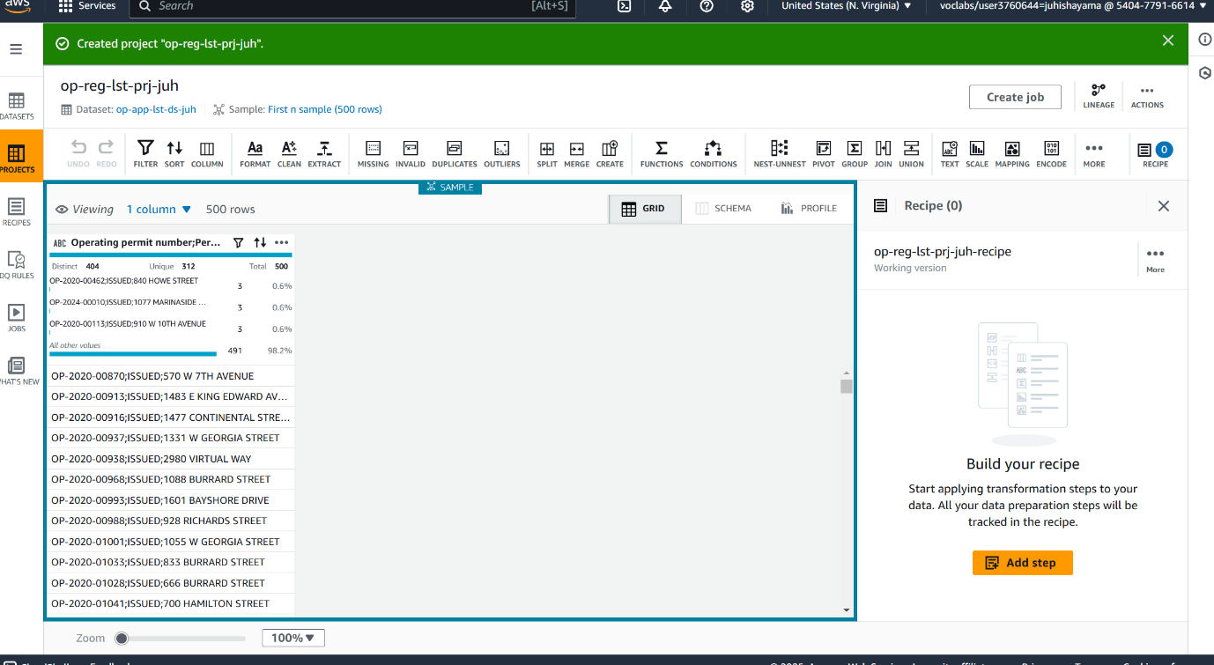

A screenshot displays the Openbank regulation list project op-reg-lst-prj-juh which currently analyzes the dataset op-app-lst-ds-juh. You can observe the first 500 rows of the dataset within this view before proceeding to add transformation steps to your recipe. Users can access an interactive interface for data profiling and preparation tasks within this system to remove null values and rename columns and standardize format specifications among others. The purpose of this feature involved preparing raw information for later processing in production pipelines. All users have access to prepare data in a trackable format using the no-code interface.

## Step 8: Data Monitoring

*Figure 10 Amazon CloudWatch – Dashboard Monitoring*

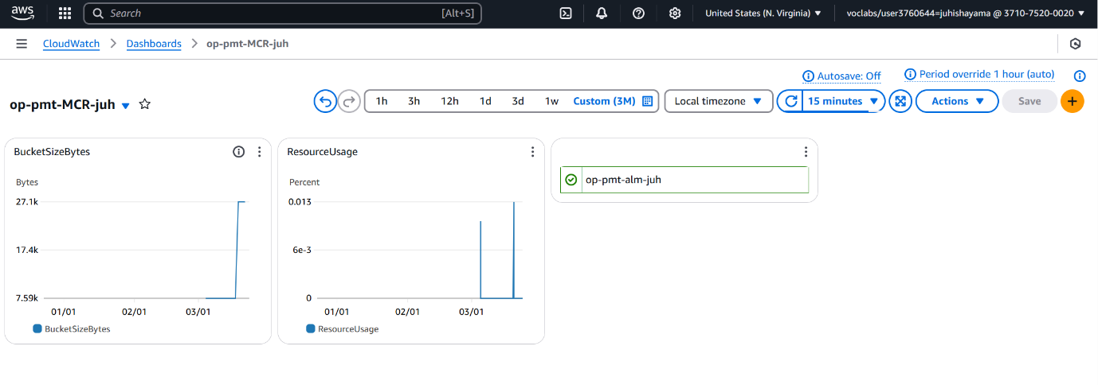

The image shows the custom dashboard named op-pmt-MCR-juh in Amazon CloudWatch that provides real-time monitoring of AWS resources. A dashboard containing the ResourceUsage and BucketSizeBytes widgets gives users storage consumption tracking together with service usage metrics across time. Teams benefit from this implementation because it helps them monitor their data infrastructure health while detecting resource limitations during their decision making process regarding resource scaling or optimization. The system enables staff to create threshold-based alerts for high availability and performance maintenance.

Figure 11 AWS CloudTrail – Logging Enabled

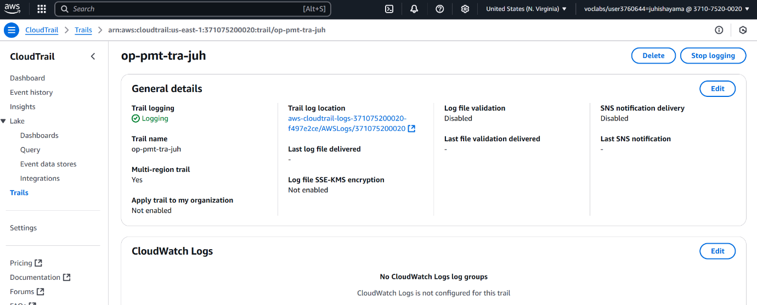

This last snapshot depicts how op-pmt-tra-juh trails can be configured for CloudTrail logging to become active. The AWS CloudTrail platform functions as a core requirement for governance and compliance and auditing needs because it monitors all AWS API activity throughout accounts. The logging system provides tracking functionalities that document resource access events and their timestamps together with geographical locations. The logging functionality maintains a critical audit trail even though the log file validation and SNS notifications pose disabled status in this configuration.

# DAP Architecture Analysis: (Teamwork):

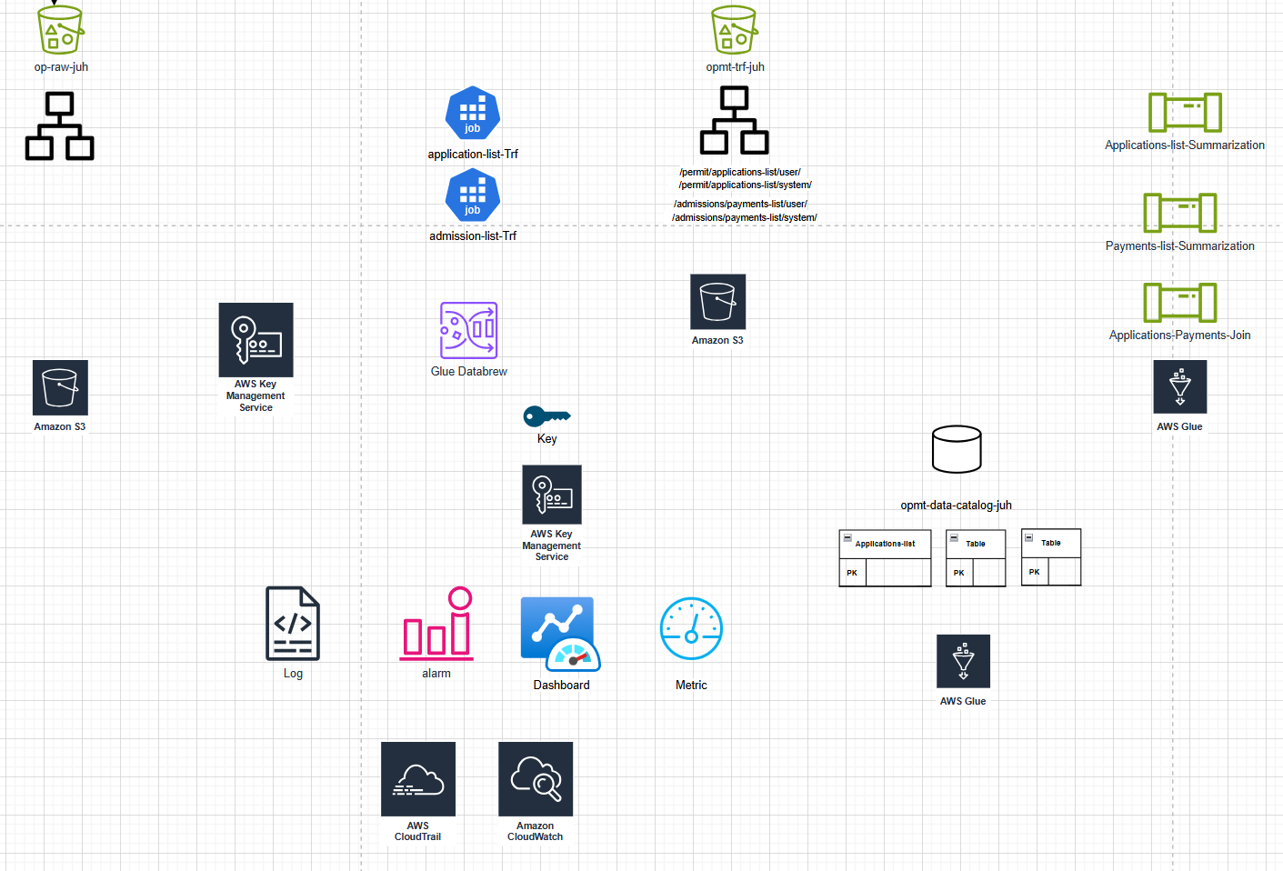

## Operational Excellence:

The project team created a Data Analytics Platform (DAP) utilizing AWS services S3, Glue, Athena and DataBrew during Part 1 development. The members used the system to run individual datasets through the workflow beginning with ingestion followed by profiling and cleaning then cataloging and summarization. The project developed reliable fundamental components along with base code operation practices yet omitted full support by automated deployment tools and AWS CDK or CloudFormation. The clear data pipeline design did not discuss essential operational excellence components such as automated documentation nor did it include version control or rollback procedures.

The project added essential aspects of data security as well as monitoring and quality validation in its development during Part 2. The system achieved strong alignment with failure anticipation by implementing AWS CloudTrail together with CloudWatch and S3 replication and versioning and KMS encryption. The team added data validation procedures which split datasets into entries that passed testing and entries that failed testing to uphold data integrity. The project failed to incorporate event and failure learning mechanisms while also missing necessary feedback systems that would enable operational procedures to be refined and event learning to be conducted from all possible situations.

The technical core implementation received proper attention from the project before Part 2 brought significant improvements to system reliability together with security measures. Urban Point should adopt four key future work initiatives that include automated infrastructure development through code together with continuous documentation maintenance and change management systems and lessons-learned processes.

Security**:**

The team in Part 1 established a data analytics platform through the integration of AWS services consisting of S3, Glue and DataBrew. Data ingestion and processing with analytics stood as the main priorities but the project had little emphasis on establishing robust security systems. Security measures were not applied correctly because least privilege access and identity management strategies remained undetermined in this setup. The data pipeline structure worked properly but it did not include necessary security configurations which included encryption methods combined with access permissions and protective measures for the infrastructure. Security events could not be prepared for nor traced because monitoring tools and incident response procedures were absent during this phase.

Security enhancements that would provide meaningful value became available through Part 2 of the project. The project added data at rest encryption through AWS Key Management Service (KMS) together with S3 bucket replication combined with versioning to properly secure sensitive information. The combination of CloudTrail with CloudWatch as activity monitoring platforms led to improved traceability and followed key security standards for the security pillar. Data integrity remained strong because the team launched their data quality classification into distinct "Passed" and "Failed" dataset categories. The existing system lacked measures to isolate network layers including VPC subnets and firewall rules as well as automated security practices and full dataset access restrictions which would boost the overall system safety.

The project development shifted considerably between Part 1 with its functional pipeline to the more secure yet monitored system implemented in Part 2. The application of essential security pillar principles progressed well except for privilege management and automated security controls and incident response planning which need improvement before meeting Amazon Web Services security standards.

## Reliability:

Within Part 1 of the project the team deployed essential ETL workflows based on AWS services including S3, Glue, Athena, and DataBrew. The data processing framework established by the structure delivered dependable data operations but proactive reliability designs were insufficient in this stage. The project lacked any mention of automated recovery processes as well as failure testing or self-maintenance capabilities during system interruptions. The AWS scalable services adoption did not include references to dynamic horizontal scaling features or automatic capacity modification methods for demand requirements. The outdated change management system operated by hand with no programmed rollback strategies to handle possible risks that updates and configuration changes would create.

The Second part of the work presented alterations that increased system resilience levels. S3 bucket replication with versioning brought a recovery solution to protect against data destruction or data corruption. CloudWatch monitoring tools became part of the project because they enable tracking system metrics along with anomaly detection. The monitoring tools operated mostly for observation purposes with no capabilities to activate automated failure responses. Recovery testing along with failure testing for understanding system behavior during stress and failure events was missing from the design although it forms the basis for long-term reliability. Automated scalability abilities that adapt to changing workload volumes would enhance the system because data classification and validation programs have already been implemented.

The project advances in step from its initial basic infrastructure stage in Part 1 to its monitored and secured status in Part 2. AWS reliability standards will be fully achieved through future development which should concentrate on testing recovery protocols and automatic failure response mechanisms along with dynamic resource scaling and automated infrastructure modification to minimize human mistakes and maximize system operational time.

## Performance efficiency:

The first stage of the project concentrated on developing an operational data analytics system with AWS S3 and Glue together with DataBrew. The team selected scalable cloud services because they provide essential performance fundamentals to their system design. The project fell short of examining complete AWS features because it did not utilize serverless capabilities (AWS Lambda) along with region-specific deployment mechanisms for optimized latency and response times. Managed platform usage in the design lacked dedicated testing of instance type variations together with storage choices or configuration factors needed for future efficiency enhancements. This plan lacked important indicators which would enable adjustments to resources according to shifting workload requirements. The project demonstrated efficiency potential yet it did not include mechanisms for real-time monitoring along with automatic scaling capabilities.

Performance needs received marginal improvements during Part 2 of the assessment period. By creating Parquet file format in S3 for data storage the platform performs queries faster while decreasing the overall costs. Making Amazon Athena available for querying data serverlessly demonstrates how organizations can reduce operational expenses while boosting performance speed. The system lacked features to show global deployment capabilities together with technology experimentation and concrete trade-off studies regarding caching or compression methods. For prototyping work the setup works efficiently yet it needs performance tracking utilities alongside systematic review processes to let the system transform when data amounts escalate or end-user requirements expand.

The project established a decent foundation through its adoption of cloud-native services that present natural scalability and economical operation benefits. The performance efficiency pillar will be better supported by automating system scaling along with performance monitoring and by using serverless computing features together with AWS’s worldwide infrastructure to maximize user experience.

## Cost Optimization:

At least three AWS service components in Part 1 demonstrated cost efficiency through their consumption-based pricing that included S3 and both Glue and Athena. Such management tactics allow businesses to pay only for actual usage. The project maintained low resource usage although it did not describe the cost analysis or tracking methods used during implementation. The assessment omits any metrics which would demonstrate workload efficiency through comparisons between cost expenditure and system productivity or time reduction achieved through AWS technologies. The project failed to demonstrate the AWS infrastructure's benefits for traditional infrastructure burden reduction as well as decreased IT operational expenses. Supply chain effectiveness would have been improved through benchmarking and usage forecasting methods that link operational needs to resource allocation for future cost optimization.

In Part 2, cost transparency improved. The project established detailed cost forecasting that showed how AWS services charged per month and year and how these rates applied to specific datasets. Such attribution methods match best practices in expenditure analysis because they enable each contributor to learn about resource use so they can potentially enhance their efficiency. Managed services including Glue and Athena help organizations lower operational expenses which subsequently decreases the final cost of ownership. The system failed to evaluate auto-scaling for demand-fluctuation matching and reserving instances or spot pricing alternatives that provide supplementary cost-reducing methodologies. The workload receives proper resource type selection but implementation of AWS Budgets and Cost Explorer for cost monitoring would lead to improved optimization in future implementations.

The selection of serverless and managed services as foundational elements by your team resulted in low predictable costs. Future iterations of the expense management system should include automated cost tracking and periodic assessments of operation efficiency together with future usage patterns so the system continuously delivers value optimally.